Annual report 2017

Fostering the Transition Towards More Fuel-Efficient Cars

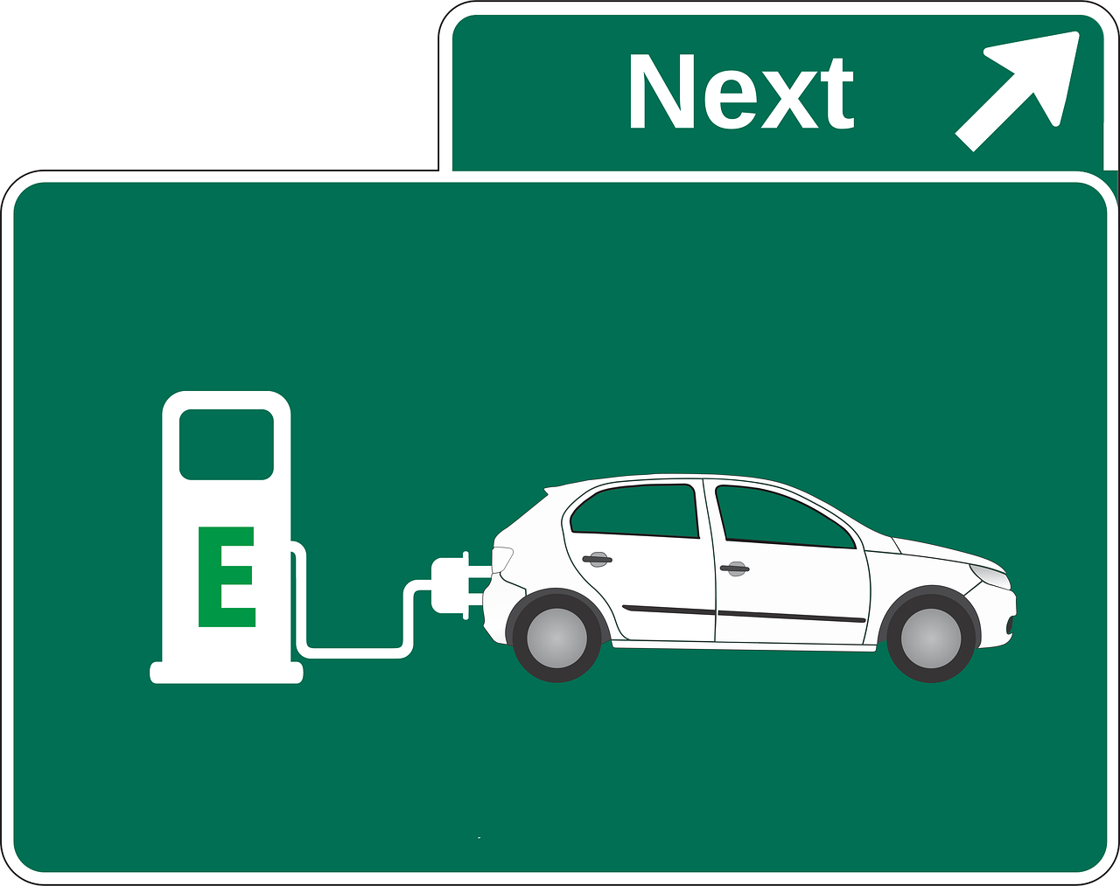

Date: 15 November 2017
Town: Zurich

Publisher:
Swiss Federal Office of Energy SFOE
XY Research Programme
CH-3003 Bern
www.bfe.admin.ch

Agent:
ETH Zurich
Institute of Science, Technology and Policy

Universitätsstrasse 41
CH-8092 Zurich, Switzerland
http://www.istp.ethz.ch

Author:
Prof. Dr. Thomas Bernauer, ETH Zurich, thbe0520@ethz.ch
Gracia Brückmann, ETH Zurich, bgracia@ehtz.ch

SFOE head of domain: Anne-Kathrin Faust, Market Regulation Specialist, Anne-Kathrin.Faust@bfe.admin.ch
SFOE programme manager: Anne-Kathrin Faust, Market Regulation Specialist, Anne-Kathrin.Faust@bfe.admin.ch
SFOE contract number: SI/8100087-00-01-05

The author of this report bears the entire responsibility for the content and for the conclusions drawn therefrom.

Swiss Federal Office of Energy SFOE
Mühlestrasse 4, CH-3063 Ittigen; postal address: CH-3003 Bern
Phone +41 58 462 56 11 · Fax +41 58 463 25 00 · contact@bfe.admin.ch · www.bfe.admin.ch

Contents
Contents 3
List of abbreviations 4
Project goals 5
Summary 5
Work undertaken and findings obtained 5
National cooperation 6
Evaluation 2017 and outlook for 2018 6
References 7

List of abbreviations
SVA car registries (Strassenverkehrsämter)

Project goals
While many sectors of the Swiss economy have in recent years increased their energy efficiency and reduced their greenhouse gas (GHG) emissions and fossil fuel dependence, the transportation sector, which accounts for around 33% of Switzerland’s GHG emissions, is lagging behind. One key part of the Swiss energy strategy thus aims to reduce vehicle emissions (and by implication fossil fuel consumption) to an average of 95 g/CO2 for new cars by the year 2021. This would help not only in reducing GHG emissions, but also in reducing local air pollution and noise. Based on currently available car models, this target could be achieved today. However, weak consumer demand for fuel-efficient cars remains a major obstacle. Previous studies on the demand for fuel-efficient cars have mostly used conventional surveys, stated choice experiments, and computational simulations to characterize the efficiency gap in car purchasing behavior. Building on that research, the project proposed here focuses on examining policy options to encourage the adoption of more fuel-efficient cars. In contrast to many previous studies, and in particular to those on Switzerland, it uses an experimental approach. The research starts with a baseline survey administered to a random sample of 3'000 car owners in Switzerland. Survey participants are then randomly assigned to one of three experimental treatment conditions: (1) information on fuel-efficient cars, pertaining to car attributes that buyers typically pay attention to; (2) information on fuel-efficient cars, pertaining to car attributes that buyers typically pay attention to, plus test-driving of a hybrid or a fully-electric car; (3) a control group with neither (1) nor (2). Two follow-up surveys, ca. two months and one year after the treatments, will assess whether these interventions (treatments) have had positive effects on desirable attributes respondents associate with more fuel-efficient cars, on their intentions to switch to more fuel-efficient cars, and how the treatments affect preferences towards a wide range of government interventions intended to increase the vehicle fuel-economy (e.g. technology standards, subsidies, taxes, and road and parking space privileges). The results of the project will provide important insights into how the government and the private sector could foster the transition towards more fuel-efficient cars.

Summary
The work undertaken is twofold. On the one hand side, we approached car registries of Aargau, Schwyz, Zug, and Zurich in order to get access to a random sample of car owners, as described in detail below. At the same time, we also prepair setting up cooperation with national car importers, in order to arrange the experimental treatment with test drives.
On the other hand, we work on a baseline survey. The baseline survey should provide us with information about the experiment participants, and their current mindset regarding fuel-efficient cars and policies aiming at facilicating their diffusion.

Work undertaken and findings obtained
This research starts with a baseline survey administered to a random sample of 3'000 car owners in Switzerland. We aim at asking the car registries (Strassenverkehrsämter) of several cantons to draw random samples of car owners and provide us with their addresses. Following the plan discussed at the SFOE kick-off meeting, we approached the registries of Aargau, Schwyz, Zug, and Zurich. We will need around 5'000 adresses from each canton (total of 20'000) in order to obtain around 3'000 completed surveys, as previous studies (Huber, Anderson, and Bernauer (2017)) show. After we looked up the legal guidles the SVAs of other cantons have to follow, with respect to providing addresses of car owners, this was feasible in the cantons named above. These policies are very similar to the one of the SVA ZH. As an indication, many cantonal SVAs offer a web-based search tool for obtaining the address of a car owner based on a car registration number. See, e.g., https://www.viacar.ch/eindex/Result.aspx. Our previous experience with SVA Zurich shows that our sampling approach is feasible and we have no reason to doubt that it isnot feasible in other Swiss cantons. We used our previous knowledge from former contacts with SVA Zurich on how to set up such a data provision arrangement, based on a Datenschutzvereinbarung, and on how to work with the IT specialists of the SVA to extract a random sample from their databases (surprisingly, the database of SVA ZH and other cantons is not organized in a way that would make it simple and easy to extract a random sample of a specific size).
Our sampling approach is clearly superior to the approach other surveys in this area have used. The prevailing approach relies on purchasing addresses from address dealers. This approach is inefficient because not every addressee owns a car. Moreover, such samples are not random samples and there is no precise information on the population from which the sample is drawn and how the sample compares to the population. In contrast, our sampling approach provides precise information on the population of car owners and the sample randomly drawn from it. This allows us to also use sample weights in statistical analysis of the data. In view of the above, we are confident that we will be able to obtain 5000 addresses from each of the cantons selected for the study.
While we have to clarify confidential agreements and some technical details with the car registries, we are already having 3 out of 4 convinced, that they will provide us with car holders’ addresses as well as some information regarding their fleet. We prefer to focus on individuals who already own a car, because it appears that it is more challenging to influence the attitudes and mobility behaviors of existing car owners than it is to influence people who may buy their first car in the future.
We will first administer a baseline survey. It will include items on socio-demographics, general political and environmental attitudes, mobility situation and car ownership, and car preferences (including envisaged future car purchases). We will use items adapted and improved from EBP (2016), MZMV, de Haan et al. (2016), and Huber, Anderson, and Bernauer (2017) as a starting point and develop them further. Mobility policy preferences will be examined using a conjoint choice experiment, which will allow us to study how individual policy instruments (e.g. technology standards, carbon taxes, road and parking space priviledges, subsidies, tax breaks, etc.) within larger policy packages affect overall support for government interventions (for method details, see Bernauer and Gampfer 2015; see also Glerum et al. 2011, and Howlett 2011). The baseline survey is now in the process of being created and improved. We especially aim to have a version we can use for the ETH Ethics comitee, in order to get the approval of the whole study.

National cooperation
We are in the process of building cooperations with four cantonal car registries, namely of the cantons Aargau, Schwyz, Zug and Zurich. Furthermore, our work towards cooperations with national car importers are in the process of being established.

Evaluation 2017 and outlook for 2018
The evaluation of the year 2017 is entirely positive. We are following our schedule as planned. All tasks we aimed to achieve in 2017 are either achieved or at the stage of the process we expected them to be at that time. This gives us hope, that we can adhere to our schedule also in 2018. The main goal of 2017’s work was to achieve a working ground for 2018. As this is achieved, we look positive to the future of the project in 2018. With the baseline survey instruments developed and the approval of the ethics comitee sought, we can start pilot testing in early 2018, which follows the time frame set. As we set up cooperation with cantonal car registries, we are able to sample the survey respondents and administer the baseline survey on time.

References
Bernauer, Thomas, and Robert Gampfer. 2015. How Robust Is Public Support for Unilateral Climate Policy? Environmental Science & Policy 54: 316–330.
De Haan, Peter, Anja Peters and Martin Soland. 2016. Die Effizienzlücke beim Autokauf: Zielgruppenspezifische Gründe und Massnahmen. BFE, Schlussbericht, 23.6.2016.
EBP. 2016. Barometer Auto und Mobilität von morgen 2016. Zollikon, 8.6.2016.
Glerum, Aurélie, Michaël Thémans, and Michel Bierlaire. 2011. Modeling demand for electric vehicles: the effect of car users’ attitudes and perceptions. Manuscript, EPF Lausanne.
Howlett, Michael. 2011. Designing Public Policy: Principles and Instruments. New York: Routledge.
Huber, Rober, Anderson, Brilé, and Thomas Bernauer. 2017. Preferences and Behavior Concerning Carbon Offsetting: An Experiment With Car Owners in Switzerland. Manuscript.

