Thema | Final report of BLV project 1.12.12 “Development of a syndromic surveillance system to enhance early detection of emerging and re-emerging epizootics and zoonoses”
Datum | 29.06.2015
Autor | Flavie Vial, Veterinary Public Health Institute, DCR-VPH, Vetsuisse Fakultät, Schwarzenburgstrasse 155, CH-3003 Bern, Switzerland

Management Summary
There are growing concerns worldwide about the emergence and re-emergence of zoonotic pathogens and their impact on animal health, public health and the economy. As a result, the European Union is reinforcing the monitoring of zoonoses and zoonotic agents within its member states and there is a strong interest in establishing reliable surveillance programmes that serve as “early-warning” systems to identify such pathogens rapidly and to implement timely and efficient disease control strategies. Switzerland currently benefits from a high standard of animal health compared to its European neighbours but is faced with the same growing zoonotic threats. The Swiss Animal Health Strategy 2010+ emphasises the role of prevention to achieve and to foster the strategic goals of animal health sustainability in Switzerland. As such, the development of cost-effective tools for animal disease and food safety surveillance is of priority to Swiss decision-makers in the field of veterinary public health. The development of a “system for early detection through syndromic surveillance” represents a concrete measure in the FVO action plan.

The overall goal of this project was to contribute to the development of a system for early detection of emerging and re-emerging diseases in Switzerland by using syndromic data already available for livestock, and by developing pattern recognition algorithms to produce alerts when such pre-selected events occur more often than expected by chance. In a first instance, several animal health datasets (both public and private), in which we identified syndromes that illustrate various types of diseases and different stages of the food production chain, were screened and assessed with respect to current availability and eligibility to produce early warning signals. Methods to exploit data on mortalities, abortions, meat inspection results, data from rendering plants etc. were developed and aberration detecting algorithms were tested. Algorithms were evaluated in terms of sensitivity, specificity and timeliness and validated through outbreak simulations. Finally, in close collaboration with the potential implementing bodies of a Swiss livestock syndromic surveillance system, solutions for technical implementations of algorithms in existing databases for real-time screening as well as a framework for evaluating such a system have been discussed.
This project serves as a stepping stone towards bridging the gaps between the Swiss animal health main stakeholders and encouraging the exchange of ideas on how to improve Switzerland’s capacity for disease surveillance and management through the harmonisation of data collection procedure and the development of database linkages for example.
Inhalt
Management Summary 2
I) What is syndromic surveillance? 4
II) Our proposed approach 8
Step 1) Define the policy purpose and surveillance goals of a national livestock SyS system 9
Step 2) Select diseases & populations for surveillance 13
Step 3) Inventory and evaluate available data sources 15
i) Health data sources 15
ii) Which variables to collect? 18
iii) How to evaluate data sources? 19
Step 4) Identify, evaluate and select syndrome-time series 23
i) Syndrome definition 23
ii) Case classification 30
iii) Describe syndrome time-series? 33
Step 5) Fit event detection algorithms to each time series & report 39
Step 6) Define an appropriate response for detected signals 47
III) Evaluation 49
IV) References 53
V) Appendices 58

What is syndromic surveillance?
The Triple-S project defines syndromic surveillance (SyS) as follows:
“The real-time (or near real-time) collection, analysis, interpretation and dissemination of health-related data to enable the early identification of the impact (or absence of impact) of potential human or veterinary public health threats which require effective public health action.”
The anthrax attacks of 2001 in the USA, and the 2002–04 outbreak of severe acute respiratory syndrome (SARS) underlined the necessity to recognise patterns indicative of a possible introduction of human pathogens, natural or not, as early as possible. SyS was developed to make use of the wealth of pre-diagnosis data automatically collected by a range of organisations such as sales of over-the-counter medicine, absences from work or school, patient's chief complaint upon emergency visit, or laboratory test orders. Due to the lack of specificity associated with pre-diagnosis data, this new type of surveillance targets general groups of diseases, or syndromes (hence the name “syndromic surveillance”). The types of events for which SyS may be useful (Figure 1) and its timeliness compared to other systems (Figure 2) are presented below.

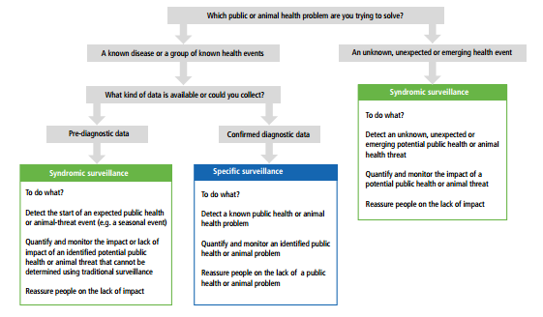
Figure 1: Decision tree for determining if syndromic surveillance meets your needs. Reproduced from [1]
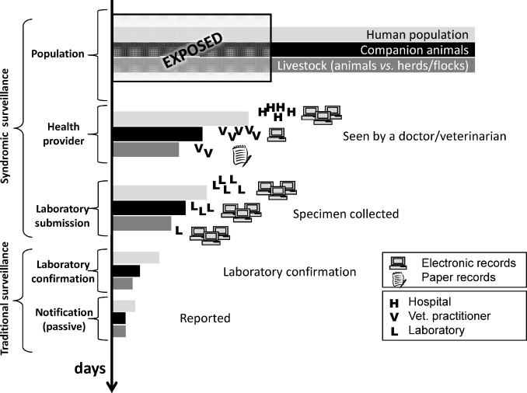
Figure 2: Schematic representation of the disease continuum in a population, and the surveillance opportunities according to population targeted, and type of data used. The scheme illustrates the proportions of subjects in each step of the disease process, for each of the three populations, in comparison to their initial population. The absolute number of livestock, companion animals and humans exposed to any given disease is not likely to be equal, and the top bars should be interpreted as the scaled total population. Proportions are illustrative only. Similarly, icons are not intended to represent a true count, but to illustrate comparative abundance. Reproduced from [2]

SyS is intended to complement specific surveillance by detecting changes or events that would either not have been detected or would have been detected later by a specific surveillance system. For example, SyS seeks to address the main limitations of passive surveillance methods based on laboratory confirmation and disease reports by clinicians [3], namely: chronic under-reporting; a long time lag between outbreak onset and diagnosis; and a low sensitivity as a result of the high specificity of these methods.

A primary assumption of any SyS system is that the behaviour of the population changes when their health is affected, and that clusters (in space or time) of these behavioral changes can be detected if the population is continuously monitored [4]. The assumption is not that the data are representative of the disease burden in the population (and usually no attempt is made to estimate such parameters, as various biases are recognized to exist), but that they are sensitive to changes to the level of disease in the population, containing an early, though weak, signature of a disease outbreak [5]. SyS based on pre-diagnostic data is particularly relevant for production animals as 1) formal diagnosis is less often reached than in human medicine; and 2) the decision to send samples to the laboratory for is mostly taken on economic ground.

Some key points regarding production animal SyS:
- It is based on non-specific and wide-ranging health indicators to help detect a broad range of events (expected or unexpected).
- It can detect known or emerging diseases for which there are no existing disease-specific surveillance systems.
- It can validate and support alerts generated by other surveillance systems
- It can identify suspected infected animals or farms for microbiological sampling (e.g. case finding during a response to an epidemic or disease eradication program)
- It can provide (near) real-time information for media enquiries about population health in the event of a public health emergency.
- It can identify potential signals and provide outputs that may help decision makers take early action.
- It can, in some cases, be relatively inexpensive to create, when based on data that are already collected.

The application of SyS for animal health is more recent but has already been described for swine [6], for cattle [7], for equids [8], for caprines [9] and for wildlife [10]. Several veterinary syndromic surveillance systems are currently in place in the EU. FarmFile in the UK has been used to collate epidemiological information on all clinical submissions received by the Veterinary Laboratories Agency (VLA) since 1998 and was developed to improve detection of new diseases [11]. In France, the OMAR project uses the National Cattle Register to monitor cattle mortality [12]; whilst in Denmark, VETSTAT primarily monitors veterinary usage of drugs in animal production but also provide data for epidemiological research [13]. Other systems in Europe include MoSS-Emergences 2 in Belgium, Kotadatabasen in Sweden, and GD Monitor in the Netherlands. An excellent overview of veterinary SyS can be found in [2].

In the Swiss Animal Health Strategy 2010+, “early detection” was identified as an important performance target in the field of “prevention”. The development of a “system for early detection through syndromic surveillance” represents a practical measure in this strategy; and in autumn 2010 experts from the different departments of the Federal Food Safety and Veterinary Office (FSVO) and representatives of the Veterinary Public Health Institute discussed potential strategies on how to proceed. The development of methods to exploit existing animal health data (e.g. mortality including abortions, meat inspection results, data from rendering facilities etc.) for SyS was identified as a necessary step towards that target. These methods are extensively presented in section II.

Despite the growing interest in SyS, there is little practical information to guide animal health SyS developers in developing and operating a SyS system. There are some publications describing methods for animal health surveillance in general that are relevant to SyS. These include: key terms and concepts for animal-health surveillance [14]; key methods for surveillance [15]; a conceptual framework for population health surveillance and foreign animal disease surveillance [16]; surveillance to document freedom from animal diseases [17] and methods for evaluating animal health surveillance [18,19]. The Animal and Plant Health Inspection Services (APHIS) from the US Department of Agriculture have also published standards focused on (1) key components, (2) data, and (3) information management for surveillance systems [20]. Similarly, the Department for Food and Rural Affairs (DEFRA) has published a list of surveillance system requirements for the UK [21]. Many SyS resources are available from the public health surveillance sector that may have relevance to animal health SyS. For example there are methods available for the early detection of disease outbreaks [22]; recommendations for SyS systems for bioterrorism preparedness [4]; many approaches for selecting, fitting and evaluating event detection algorithms [23]; and methods for evaluating public health syndromic surveillance [24].When this project started in 2011, no practical, animal health specific SyS guidelines had yet been published. This is likely because SyS in animals, was relatively new and also because there was considerable variation among the approaches to SyS for livestock [2,25]. This spurred John Berezowski and I to develop and publish a practical approach to designing a SyS system for livestock and poultry [26].

Proposed approach
Project management methods have long been used to support science in building evidence that can be delivered within finite resources and funding [17]. The 6-steps (Figure 3) approach we have put forward for the development of SyS for production animals in Switzerland [26] loosely follows the population health surveillance theory outlined in [16].

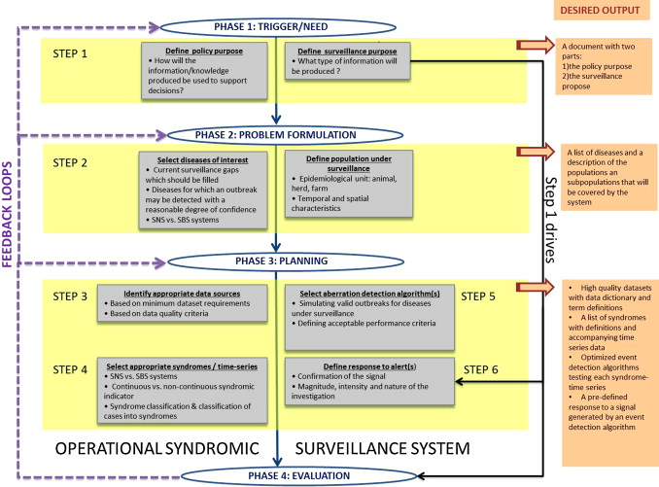
Figure 3: Proposed conceptual steps to be undertaken before operating a national SyS system. Reproduced from [26]

Define the policy purpose and surveillance goals of a national livestock SyS system
The SyS policy purpose is a set of statements describing how the surveillance information will be used to support decisions. It can also be thought of as the need that triggered the development process (Box 1). SyS can cover a wide range of policy purposes, for example:
- Detection of unexpected health threats.
- Early-warning: detection of start of expected event (e.g. seasonal flu).
- Situational awareness: quantify & monitor the impact of identified threat (severity, geographical extent, population at risk…).
The policy purpose is critically important because it will guide the design of the SyS, define the SyS outcomes and information produced (the surveillance objectives), and provide standards against which the SyS will be evaluated. For example, the policy purpose will dictate:
- Whether the SyS system will be used for specific disease(s), or to detect a non-specific change in the health of a population that will be requiring further investigation?
- Whether the SyS system will be designed for short-term/ high-risk situations or long-term/ continuous use?
- The operational scale of the SyS system: small scale (farm level) vs. large scale (national)?

Box 1: Possible policy purpose of animal SyS in Switzerland (suggestion):
Why does Switzerland need an animal health strategy? In “Swiss Animal Health Strategy 2010 +”
“In a comprehensive sense, animal health includes measures and conditions to eliminate or significantly reduce the impact of diseases on animals including their wellbeing environments. According to animal health legislation and the threat situation outlined, the public veterinary service focuses in its “Swiss Animal Health Strategy 2010 +” on infectious diseases and, in particular, on zoonoses (diseases that are directly or indirectly transmissible from animals to humans). Thereby impeccable primary production with healthy animals is crucial for the production of safe food.”
Hans Wyss, Director of FSVO

The FSVO needs a wide range of information in order to make decisions about the mitigation of infectious animal diseases. Mitigation, as defined in [27], is “the process of making the effects of disease less severe by avoiding, containing, reducing or removing it”. As such, both surveillance and intervention activities are part of a mitigation strategy. Effective surveillance helps to offset the negative effects of disease on animal and food production by promoting successful interventions. Häsler et al. [27]divided the mitigation process into three stages (sustainment, investigation and implementation) each requiring different surveillance objectives (Figure 4). At the start of the mitigation process (the sustainment stage), a pathogen is viewed as either absent or present at an acceptable level. The surveillance objective during that time is to document that a pathogen remains below a defined threshold, and to provide early warning of an increase in incidence or other significant changes in risk (e.g. higher pathogenicity, new subtype). If the pathogen cannot be contained (the investigation stage) surveillance activities seek to obtain critical epidemiological information (e.g. disease incidence or the direction/rate of dispersion) to inform decisions about the intervention strategy (e.g. timing and scale). During this implementation stage, surveillance documents the progress in the light of interventions. Since livestock SyS is a relatively new addition to the surveillance toolbox, it is likely that the full utility of SyS has yet to be discovered and we expect the range of achievable objectives to expand as animal health SyS continues to grow (Box 2).

Figure 4 : Schematic illustration of surveillance objectives in relation to a three stage mitigation system. A: (re-)emerging or exotic epidemic pathogen that is not controlled by response measures, B: (re-)emerging or exotic epidemic pathogen that is controlled by response measures, C: continuous free status, D: endemic disease, dotted line: true value unknown. Reproduced from [27]

Box 2 : Possible goals of animal SyS in Switzerland (suggestions):
- To detect incursions from formerly unknown diseases
- To support the work of the existing animal health surveillance and notifiable diseases systems
- To detect earlier bovine viral diarrhea incursion on herd-level earlier than with traditional surveillance sytems
Note: In Switzerland, it may be necessary to differentiate between ”government-led” SyS activities/goals that will focus on diseases (Step 2) that affect trade or public health (Tierseuchen) from those led by industry groups (and Früherkennung?) which may seek to encompass a broader range of diseases including those that affect productivity (Produktionskrankheiten, keine Tierseuchen) in addition to those that affect trade.

Early on in the development of the SyS system, a steering group made up of all influential stakeholders should be created (Box 3). The group should include those who provide data for the system (data providers and managers), those who design and operate the system (statisticians, epidemiologists, funders) and those who will use the information generated by the system (decision makers). The whole group should be engaged in the process of defining the SyS objectives. These should be: 1) relevant; 2) detailed, precise and formalised; 3) considerate of stakeholder expectations; and 4) should reflect priority issues (OASIS criteria developed by [28]). In addition, they should be technologically achievable within the available budget, and they should be valid scientifically. Ideally, consensus on the SyS objectives should be achieved.
Box 3: Tasks of steering group of animal SyS system in Switzerland:
- Define purpose and goals of the SyS system (Boxes 1 and 2)
- Identify infrastructure on which the SyS system would rely (Table 1)
- Define roles, responsibilities and expectations of stakeholders
- Ensure participation of data providers (limit additional burden to their work & solve issues of data governance)
- Identify links with other surveillance systems including wildlife & human.
- Define a protocol for investigating alarms and communicating alerts (Step 6)
- Define the criteria for evaluating the system (and who will do it) (Section III)
- Discuss the added value and feasibility of European comparability
Note: In Switzerland, the tasks above have already been undertaken and discussed within the projects “Equinella” and “Netzwerk Rindergesundheit/Netzwerk TGDataS”.

The group may be large and will likely be diverse in terms of desired objectives and views of SyS capabilities. Reaching consensus may be a challenge.

Table 1: Examples of resources needed to establish SyS systems at minimum and enhanced levels. Reproduced from [1].
Level | Human resources | Infrastructure
Minimum level | Data analysts (*2)  Scientific assistant (*1)  Senior epidemiologist ª (*1)  IT (*1)  Communication ^{b} | Computers  Software  Phones  Other
Enhanced level: additional suggested resources to improve the system or manage multiple systems | Medical epidemiologist (*1)  Scientific assistants (*2)  Experienced statistician (*1)  Administrative support (*1)  IT (*1)  Business and communication support ^{c} (*1) | Computers  Servers  Offsite backup servers  Software  Phones  Other
ª The epidemiologist should have substantial experience in statistics and data analysis.
^{b} Communication should form part of the system’s work.
^{c} Ideally, there should be a clear link between the organisation’s communications or media professional and the system owners in both day-to-day communication and in time of crisis/incident. The communication strategy of the SyS system should be linked to that of other existing surveillance systems (sharing media professionals if possible). If a dedicated website is planned, sufficient resources are needed for updating and maintaining the site.

Select diseases & populations for surveillance
It is necessary to define the health event that the system is intended to monitor (Box 4). The surveillance goals set in Step 1 will dictate whether the SyS system will be ‘‘syndrome-based’’ (SBS), ‘‘syndromic-non-specific’’ (SNS) or both [29]. Whereas SBS focuses on monitoring defined syndromes, diseases or outcomes of interest (e.g. a specific disease(s) or influenza-like illnesses), SNS aims to monitor non-specific indicators such as the number of dead stock picked up by rendering companies, or the sales of antimicrobial pharmaceuticals. SBS would enable situational awareness for defined health threats, and could be used to identify clusters of excess cases with specific disease characteristics that might represent an outbreak with a defined cause. An example is a geographic cluster of samples from aborted material sent to the laboratory for Brucella testing. Such data are still syndromic because they are pre-diagnostic (a request for a Brucella test does not necessarily mean the sample will be positive), but they are based on clinical suspicion providing some indication of the type of disease occurring in the cluster. On the other hand, a SNS would focus on identifying unexpected excesses of indicators that could be caused by unknown, unspecific or many disease processes, making SNS useful for detecting previously unknown and unseen diseases.

A SBS should target those diseases that are of importance to the national animal health community. As such, it is important to find consensus on national priority diseases and then to identify current surveillance gaps which should be filled by the future SyS system. Many livestock and poultry diseases could be of interest to SyS system designers (depending on the goals defined in step 1 above). These could include any or all of: OIE listed diseases, endemic diseases, sporadic diseases, exotic diseases, re-emerging diseases, new (emerging) diseases, zoonotic diseases, production diseases, and diseases that affect trade.

Depending on their nature, diseases will be differently expressed in space, time, and demographic strata of the livestock population. The geographic, demographic, and temporal coverage of the SyS system must therefore be sufficient to support anomaly detection. It may be relatively easy to define the adequate level of aggregation (e.g. age, production type) in a SBS system with known risk factors for specific diseases. However it is often difficult to identify a priori the subpopulation groups for SNS systems which aim to detect unexpected events. Similarly the most suitable spatial scale cannot be easily defined: a system able to identify problems at the herd level could be the most convenient for risk managers, whereas significant abnormal increases in the syndromic indicator may only be possible at the regional or national level [30]. The target population about which statistical inference will be made should therefore be defined in terms of 1) animal or group type; 2) epidemiological unit (animal, herd, region, etc.); and 3) administrative unit (e.g. county, region, canton, district etc.). Both the targeted population and targeted health threat(s) should be taken into account in step 3 when evaluating potential data sources (Box 5).
Box 4: Possible diseases monitored by the animal SyS system in Switzerland
The surveillance goals set in Step 1 will dictate whether the SyS system will be ‘‘syndrome-based’’ (SBS), ‘‘syndromic-non-specific’’ (SNS) or both. However, some surveillance activities already in place already collect both SBS and SNS data which may be integrated (depending on policy purpose and goals) in a future SyS system.
SBS data:
- Equinella: clinical suspicions (pre-diagnosis) of several non-notifiable equine diseases
- Official laboratories: samples received for a particular test

SNS data:
- Equinella: reporting of fever, diarrhea…cases
- PathoPig: use of antibiotics, resistance to therapy, mortality…
- LyMON: altered lymph nodes of slaughtered cattle

Box 5: Target populations for the animal SyS system in Switzerland:
The surveillance goals set in Step 1 will dictate whether the SyS system will be ‘‘syndrome-based’’ (SBS), ‘‘syndromic-non-specific’’ (SNS) -or both- and the target populations. However, some ongoing surveillance activities, which may be integrated in a future SyS system, cover the following populations:
Datasource | Animal type | Epi. unit | Admin. unit
Equinella | Equids | Animal | Community?
Laboratories | Cattle, Swine,  Small ruminants, Equids… | Animal or herd | Community? Canton?  CH?
PathoPig | Swine | Animal | Canton?
LyMON | Slaughtered cattle >3 years | Animal | Slaughterhouse? Canton?

Inventory and evaluate available data sources

Health data sources
A data source can be chosen anywhere along the continuum of the disease process, the animal life cycle, or the production chain. It may originate from producer or professional organisations [31], private practitioners [32], diagnostic labs [33], government agencies [30], and businesses such as slaughterhouses [34] and livestock markets [9]. The data source for a SyS system whose main objective is early detection will need to be one that collects data early in the onset of the disease (or earlier than other surveillance systems)(Figure 5).
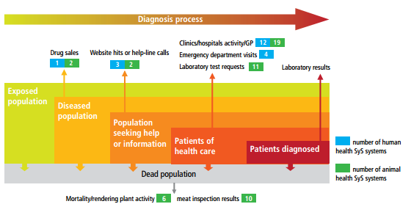

Figure 5: Human and animal health data sources by underlying infection and associated behaviours. Reproduced from [1]

The relevance of the different data sources will be different for SBS or SNS SyS systems. For the former, clinical pre-diagnostic data will preferentially be used, and for the latter, a combination of pre-clinical and/or clinical pre-diagnostic data will be more appropriate. Data sources with relatively long history will be preferred as the availability of baseline data will make the fitting of aberration detection algorithms (step 5) easier.

The availability of each data source must be precisely established. SyS that is based on existing data is a secondary use of data, meaning that the data are collected for some other, often non-surveillance purpose. Many of these data are in databases controlled by people or organizations that are different for the organization conducting the SyS (Box 6).

Box 6: Possible SyS animal health data sources
- Veterinary clinics: data based on the clinical diagnoses made by veterinarians for a range of medical conditions.
- Slaughterhouses: meat inspection is conducted in every European slaughterhouse to ensure the food safety of meat products. Inspection can produce valuable indicators for SyS (e.g. condemnation rates, the frequency of reasons for condemnation). Slaughterhouses are particularly interesting since they represent the final destination of most livestock and so have high population coverage.
- Laboratories: When the first clinical symptoms occur in animals, veterinarians make a list of suspected diagnoses and request laboratory tests to confirm their hypothesis. By monitoring the number and type of requests for testing, emergence of diseases could be detected earlier.
- Farmers or professional organisations: farmers or breeders’ associations usually collect production data for monitoring their activities (e.g. milk production level and quality, fertility). Since a drop in production can be an early sign of disease, production indicators may be suitable for use in SyS systems.
- Volunteers self-reporting: a network of participants (e.g. veterinarians, farmers) report cases on a voluntary basis.
- Rendering plants: according to European legislation, “fallen stock” represents a risk to public health and must be rendered in authorised plants. The legislation also specifies that any person (public or private companies) collecting and rendering animal cadavers has to record the following information: quantity collected, identification number, date and place of collection. Many rendering plants collect additional information (weight of cadavers, production type) for their own purposes or because of specific national regulations.
- National cattle registers: They represent another important source of data on cattle mortality and reproduction (e.g. calving interval). Cattle owners have to report within seven days all movements to and from the holding, and all births and deaths of animals on the holding, along with the dates of these events. These registers are supposed to be comprehensive and rapidly updated, and so may be suitable for implementing real-time mortality surveillance systems.

In some cases, the data in these databases may have originated from third parties, and this can have important legal and ethical implications (Box 7). For example veterinary practices collect and store data about diseases that occur on their clients’ farms as part of their medical and billing records. Who has legal ownership of these data will be defined by the laws in the jurisdiction where the farmer and the veterinarian reside. Regardless of who owns the data legally, veterinarians will often wish to keep their clients data confidential if for no other reason than to safeguard the trusting relationships they have built with their clients. A data sharing and use agreement that protects the confidentiality and privacy of all data providers and very clearly defines the terms of use of the data is essential. These should be initiated by the SyS operator as many individuals and organizations that collect or hold data may not have previously dealt with this issue.

Negotiating the terms of use of the data and the information generated from it is a worthwhile process as it is an opportunity for the SyS provider to explain the purpose of the SyS, who will benefit from the SyS, how the data will be used and protected, and the risks for participating. It also precipitates discussion about the acceptability by the data provider and all stakeholders of the consequences of an outbreak suspicion. System developers should make sure that the owners and providers of the data are aware of the potential consequences of data sharing. A farmer who is contacted by a team investigating a potential disease outbreak on his or her farm without being aware that he or she has been contributing data via their veterinarian to a SyS system could harm all parties (farmer, veterinarian, and SyS operator). Data use agreements must also specify the terms of communication of information derived from the data. Communication of any identifying information in a public forum about the occurrence of a sensitive disease can significantly and sometime irreparably damage a farmers’ livelihood or potentially the industry as a whole.

Box 7 Main characteristics of available animal health data sources in Switzerland:

Which variables to collect?
Data providers will usually be able to communicate a list of the health and health-related variables that they normally or could easily collect. The main variables of a SyS will be health variables:
- Unspecific clinical data (e.g. symptoms, provisional diagnosis)
- Proxy measures of population health (e.g. drug sales, carcass condemnation rates)
- Treatment/prescriptions (may be used to monitor changes in the severity of an evolving outbreak)

In order to ensure the data source’s representativeness of the target population, information on demographics should be available such as:
- Age
- Sex, neutered status and parity
- Species, breed and production type

To choose the most appropriate scale for the SyS system, geographical variables need to be collected. This will determine the smallest area unit available:
- Country
- Canton
- Postcode/Municipality
- Herd: the most relevant epidemiological until for production animals’ health. However, the number of occurrences of a syndrome will often be low at this level, resulting in the need to group counts over a longer time-scale (which will reduce timeliness) or over a larger geographic area (which may be recommended for confidentiality purposes).
Provided fine-scale geographic information is available, it can also subsequently be used to map the origin and spread of outbreaks.

Discussing the future SyS data with statisticians will ensure that all the variables necessary for the analyses (e.g: is a denominator required?) are available and in a format that allows appropriate analyses and meaningful interpretation of the data. A useful endeavour in this phase is to develop minimum data requirements to achieve all surveillance objectives while minimizing the amount of data collected, especially eliminating data with no direct added value for analysis or reporting [35]. Such minimum dataset should contain signs/symptoms and proxy; demographics (at least species, age and production type are a bonus when available); geographical information and temporal information (e.g. date of call/visit).

How to evaluate data sources?
One can then compile an inventory of the data sources that are available and evaluate each using the criteria developed. We suggest at a minimum to use the following evaluation criteria:

Data dictionary:
Since many SyS are secondary data uses, it is likely that the data being considered for SyS were collected by someone other than the SyS operator. A data dictionary that is a clearly written, easily understandable description of the names of the values (terms) in each variable is essential, as is a definition for each term in each variable. It is essential for understanding the data and more importantly for understanding how the data relate to the population under surveillance. Knowing the meaning of the terms used in the data will be essential for defining the syndromes and time series that will be monitored for detecting disease outbreaks. Finally having well-defined terms will allow comparison of SyS results between different data sources, SyS systems and across jurisdictions. This would be further facilitated by having internationally agreed upon standards for SyS terminology; however these have not yet been established.

Recording:
All data should be electronic. The main difference between various data formats is the extent to which they are structured (Table 2). The description of the system's data management should address who is allowed to enter the data, how and at what levels the data can be edited, and what checks are in place to ensure data quality (spelling, missing fields etc.). Training may have to be put in place to ensure that all data providers are aware of data quality requirements. Ideally, the data provider is able to incorporate the dataset collection into an existing reporting schedule without incurring any additional work. However, there will be times when a bespoke data collection system will need to be developed, resulting in additional costs.

Table 2: Different data formats that can be used in SyS systems. Reproduced from [1]
Format /Description | Pros | Cons
Spreadsheet :  Excel spreadsheet  or spreadsheet from  ‘Office-like’ software | Little IT experience required in  order to manipulate data.  Can analyse data straight away. | Large file sizes; limited  flexibility with data storage.  Does not hold data in multiple  relations like Access or SQL.
Text files :  A string of text  delimited by comma,  tab, semi-colon etc. | Easy to import to a database, for  example Excel or SQL. | Not able to immediately  analyse data in this format.
CSV :  Stores tabular data  (numbers and text)  in plain-text form | Simple file format, widely used.  Most programmes support CSV  iImport. | Each line only corresponds to  one record or case in a dataset  i.e. ‘flat’ structure.  Very simple, but inefficient and  inappropriate for datasets with  any complex structure.
XML :  XML is a mark-up  language with tags  to define data | XML was created to readably  structure, store and transport  information for database imports.  XML is the most common tool for  data transmission for many types  of application, especially the web,  where it can be automatically  compressed.  Structure of XML allows data to be  imported into multiple relations in  a relational database.  Support of the Web Services  Technology. | XML is designed to carry data,  not to display data.  XML syntax is verbose and  relatively long.
JSON :  JSON is a simple  but complete data  format for web  services | Increasingly common, strongly  structured, flexible, simpler to use  than XML. | Not yet widely used.

Compliance:
It is important to assess the completeness of the data as this will have a direct bearing on the value of the data for SyS especially in terms of the validity of SyS signals. This can be done by estimating the proportion of missing values for each variable and eliminating those data sources with too many missing values.

Transmission:
The minimum dataset then needs to be extracted and transferred to a central unit. A well-integrated system should seek to increase timeliness by meeting the specific primary data collection needs of the providers while avoiding the duplication of effort. In non-integrated reporting systems, the compliance of the data provider to timeless will depend on their primary use of data and their motivation for reporting it. Automated systems are the most favourable since they minimize the amount of work required by the data provider. However they may be difficult to install in some proprietary software and some software providers may not allow additions to their software. In some cases it may be necessary to seek assistance directly from the software provider to construct data export software [36]. The system for transmitting data should also require little maintenance and not rely on specialised support for maintenance. Transmission should be electronic, secure and encrypted (e.g. secure email, secure web server, secure File Transfer Protocol). Transmission that is frequent (e.g. daily when possible) and early (e.g. in the morning to allow for real-time public health reaction) should be encouraged.

Compilation and aggregation:
In situations in which data from several providers needs to be simultaneously considered, a further step of data compilation must be undertaken. Issues of data privacy and data sharing may become apparent then. Customised data extraction and compilation software may need to be developed [36] to automatize the process of data standardisation between providers and potential linking of animals or animal premises between the various databases using universal identifiers.

Accuracy of the compiled/received data:
Once the data have been compiled in the SyS database it is essential to confirm that the data which has been transmitted and compiled is in in fact the same as the data that is present in the data providers’ database. This can be done by selecting a random sample of cases in the SyS database and comparing them to those same cases as they are recorded within the data providers database [36].

Epidemiological evaluation:
Criteria and methods for evaluating data sources for disease surveillance have been developed for human systems and are thoroughly discussed in the public health literature [37,38]. One important consideration is how well these data match the required coverage set in step 2 in terms of catchment area/population for surveillance. Does the data adequately cover the populations, subpopulations or production types and the geographic regions that are required? Another consideration is timeliness; some data even if they are collected in real time may not be reported to a central database for days or weeks and will have little value for early disease detection. The technological infrastructure available for the SyS must at some point be considered. Institutional constraints on software availability and Information Technology (IT) infrastructure will affect the functionality of the SyS and may make it impractical to deal with some data. Each institution is likely to have made organisation-wide decisions about the software that is permitted for use for data bases, data transfer, data analyses, data reporting, as well as rules about using open source versus proprietary software. In addition, human resources may be limited, making it difficult to complete certain tasks such as building tools to transfer data to the SyS database from external databases.

We have discussed SyS based on the secondary use of data that is already being collected for other purposes. However, there may be situations where there are insufficient data sources available to allow the SyS to achieve the defined purpose and goals. If this is the case, the SyS designer will be faced with the additional task of developing data collection tools and enrolling the appropriate data providers. Designing the data collection tools provides the SyS designer with control of the data that will be collected and enables collecting data that meets the purpose and goals of the SyS. However there are many additional factors that will need to be considered when designing purpose-built data collection tools. While a detailed description of these is beyond the scope of this report, there are a few things that should be mentioned including: determining the best vehicle for data collection (e.g. paper, web page, smart phone app, etc.) that best aligns the purpose of surveillance with the technical abilities of the data providers; following best practices for questionnaire design, especially with respect to keeping the burden of data entry in terms of time and difficulty to a minimum; and developing strategies for timely and sustainable data submission. The last point is extremely important because it will affect not only the sensitivity of the system, but also the long term sustainability of the surveillance. Strategies include payment [39] for timely data submission and returning valued information to the data providers [40].

Identify, evaluate and select syndrome-time series
This step consists of two consecutive phases which are needed in order to have the required set of syndrome-time series ready for the fitting and evaluation of aberration detection algorithms (Step 5): a syndrome definition phase followed by a case classification phase.

Syndrome definition
A syndrome has been defined as “a set of non-specific pre-diagnosis medical or other information that may indicate the release of a bioterrorism agent or natural disease outbreak” [29]. Public health SyS is based on the premise that a significant change in the health of a population will result in an accompanying change in the behaviour of the population [4]. Similarly, a significant change in the health of an animal population should be expected to result in an accompanying change in the behaviour of the animal population and, or, the human population that cares for the animal population. Therefore, for animal health SyS, a syndrome can be any indicator originating from the animal population, animal care giver population or other source, that accompanies a significant change in the health of the animal population.

Based on the output of step 3, a list of syndromes should be produced for all data sources whose monitoring is considered potentially useful for the SyS being developed. The inventory should not necessarily be exhaustive, but rather tempered by an understanding of how the diseases selected for SyS could be expressed in each syndrome and the characteristics of each syndrome. The syndromes defined should ideally lead to high performance outbreak detection (i.e. high specificity for the disease(s) under surveillance and highly sensitive for early detection of outbreaks of those diseases).

The syndromes most often used in SyS are categorical variables (continuous variable SyS is much less common and will not be considered here). For analyses, syndromes are converted into time series, which are counts of the syndrome occurrence per unit of time. A working definition for a particular syndrome should include the syndrome being counted, the unit of time, as well as other contextual information such as the geographic region, production type, sex, age, or other important information. An example is the number of occurrences of acute diarrhoea in pigs per week in Switzerland. The syndrome that is counted is diarrhoea. The time units are counts per week. The contextual information includes the species: pigs, and the geographic region: Switzerland.

Coding systems are lists of possible values used to code the health information (e.g. observed symptoms or provisional diagnosis). Some data providers may already use a coding system for their data. It may therefore be necessary to evaluate its usefulness for SyS (Boxes 8 & 9), i.e. one should easily be able to map the records to the syndromic indicator of interest. If this is not possible, the data source may not be integrated in the SyS; a new coding system may need developing; or tools capable of using animal-health ontologies to classify animal health records into syndromes in an automated, harmonised way (Box 10).

Box 8: Syndromes from the Fleischkontrolldatenbank (FLEKO)
Reasons for whole carcass condemnations are listed in the Swiss legislation. Overall, between 55 and 59% of condemnation codes were used with a frequency of less than 1% for the three animal types (Table from [60]).

Each type of production animal appears to have a specific profile when it comes to reasons evoked for whole carcass condemnations.

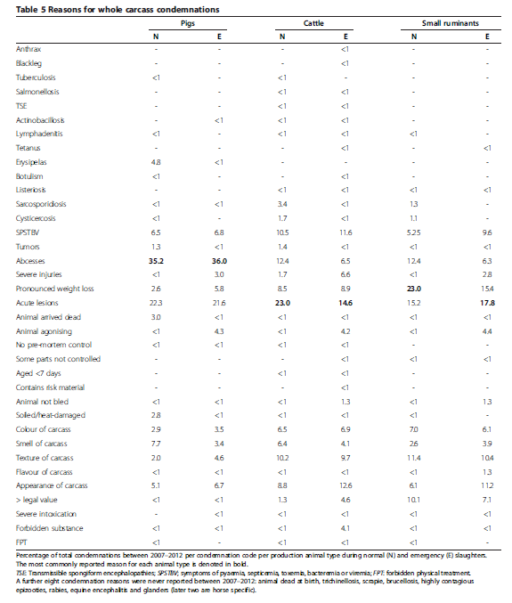

Box 8: (continued)
“Acute lesions” was the most common cause of carcass condemnation for cattle (both normal and emergency slaughters) and small ruminant (emergency slaughter); while abscesses were the most common cause for pigs (both normal and emergency slaughters). Pronounced weight loss was the most commonly reported cause of condemnations for small ruminant condemnations during normal slaughter. These reasons could constitute valuable syndromic indicators as they are unspecific clinical manifestations of a large range of animal diseases as well potential indicators of animal welfare. Similarly, condemnations for severe injuries or pronounced weight loss could be used, among others, as animal welfare indicators to identify farms on which management practices could be improved.
The 44 condemnation codes could be grouped into 5 major categories (see below). The first 20 codes (in blue) are related to specific diseases, 6 codes (in green) describe general poor health symptoms, 9 codes deal with characteristics of the slaughtered animal (in purple), 5 with meat quality (in yellow) and the final 4 with treatments received by the animal on the farm (in orange).

The 6 condemnation codes highlighted in green would be most appropriate for inclusion in a SyS.

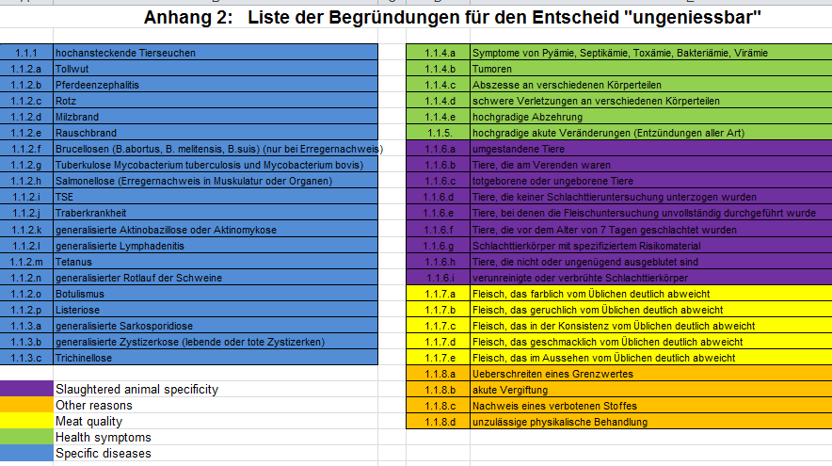

Box 9: Partial carcass condemnations recorded by slaughterhouses [61]
Currently, the FLEKO only contains information about whole carcass condemnations. Partial carcass condemnations (PCC) do occur at a much higher frequency but their declaration to the Federal Office is not compulsory. As such, each slaughterhouse record PCCs differently in their own systems using different coding systems (an example is provided below).

Many of these codes can be grouped by organs (see below), some of which (like liver, kidneys or lungs) may be of interest for SyS.

Cattle from the same herd are frequently slaughtered in different slaughterhouses. To allow PCC data to be used for SyS and early detection, a standardised list of reasons for PCC needs to be defined and used nationwide in all slaughterhouses.

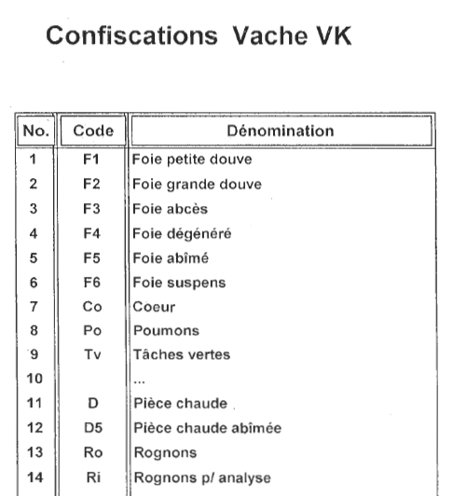

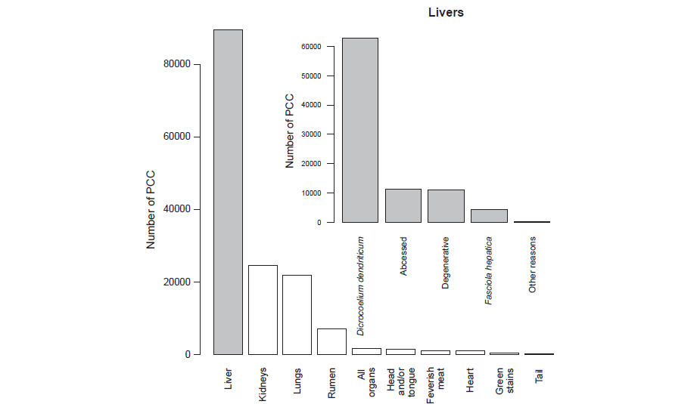

Box 10: SSynCAHD - Development of an ontology for syndromic classification of animal health data
The National Veterinary Institute in Sweden (SVA), in collaboration with researchers from the Centre for Veterinary Epidemiological Research (CVER) in the Atlantic Veterinay College in Canada, the Veterinary Public Health Institute (VPHI) from the University of Bern, Switzerland, and the French National Institute of Agronomic Research (INRA), have launched a project entitled “Standardising Syndromic Classification in Animal Health Data (SSynCAHD)”. Recognizing that institutions will continue to record animal health data according to their own standards and vocabularies, and recognizing also that data sharing across countries is not easily achievable, SSynCAHD proposes to harmonise syndromic surveillance data use rather than data recording. That would be achieved by standardising the classification of records into syndromes. The advantages would include: an ability to achieve syndromic classification from different sources of data which are (and will continue to be) recorded using the institution’s own vocabulary; the ability to compare VSS system outputs; and the more timely development of VSS systems.

In order to achieve that, SSynCAHD will make use of current technologies of information management and sharing, which are aimed at promoting intelligent access to data. In particular, SSynCAHD will be informed by the latest thinking relating to the Semantic Web, which supports the development of frameworks to maximize the potential of data sharing and reuse.

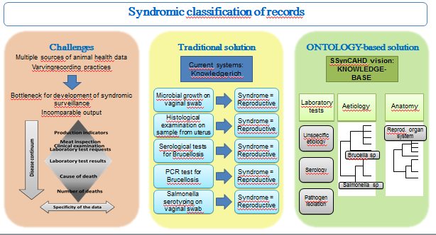

Syndromes vary considerably, from non-specific surrogates for disease to very specific case definitions that could be used for detecting an outbreak of a single disease or for disease intelligence during an outbreak. Defining syndromes will be dependent on purpose of the SyS and the contextual information present in the data. For SNS SyS, the syndromic information is by definition non-specific. In addition, the contextual information in the data may be limited and this may restrict the range of available syndromes. In the example of the counts of dead animals picked up by a rendering company, the only syndrome available in the data may be the count of dead animals per unit of time. For data that are used for SBS SyS such as veterinary practitioner data there may be a lot of contextual information present and it may be possible to subset the data into more specific syndromes-time series. In the diarrhoea example above, if the age of the pigs were available the specificity of the syndrome could be increased by monitoring the counts of acute diarrhoea in neonatal piglets less than 2 weeks of age. Since many gastrointestinal pathogens of pigs are age-related this would narrow the number of diseases detected by the syndrome-time series considerably. If information about the within litter prevalence of diarrhoea in neonatal piglets was available, it could be possible to be even more specific by including only farms where neonatal piglets had diarrhoea with very high prevalence. This would further restrict the number of pathogens that could potentially be detected by the syndrome-time series. Other factors that may be used to subset the data include the production type, for instance dairy versus beef for cattle, or the geographic region (community versus canton versus country).

It should be noted that event detection algorithms are statistical tests that are run on each time series with each time unit of analysis. Most importantly, they are subject to error. Sub-setting the data into more narrowly defined syndrome-time series may have the desired effect of increasing the specificity of each syndrome-time series by reducing the number of diseases detected, but it will increase the total number of syndrome-time series that must be tested. For a fixed value of statistical significance, increasing the number of tests run every time period will increase the number of false positive results generated by the whole system. Raising the level of statistical significance for each algorithm may not be the best solution as this will reduce the sensitivity of each individual algorithm

Using well defined and accepted terminology for defining syndromes is important for all stakeholders including those who enter the data, surveillance epidemiologists, and the decision makers who use the information generated from the data. In addition commonly accepted definitions for syndromes and other terms are necessary for comparing SyS findings across jurisdictions. Case definitions might exist for a variety of health-related events under surveillance (e.g. in the Systematized Nomenclature of Veterinary Medicine SNOVET) as they do in public health surveillance [41]. If an official definition does not exist, one must be agreed upon by the system users (a sort of gold standard).

Case classification
For some data sources, cases will have already been classified into syndromes. However, for the others, each case (record) will have to be classified into a syndrome class using text-mining and logic rules (Box 11). Both supervised, such as diagnostic learning and rule-based methods as in [42,43], and unsupervised methods, such as multiple factor and cluster analysis as in [44], are available. Even automatized syndromic case classifiers are not 100% reliable. A note of caution regarding the substantial heterogeneity of findings constituting the syndromic case definition can be found in [45].
Box 11: Post-mortem reports classification
Post-mortem data were collected by the Institute of Animal Pathology (ITPA) of the Veterinary Faculty at the University of Bern between 2000 and 2011. The data had been entered into a database using proprietary software. The reports are mostly written in German. Each report entry covers information about the owner of the analyzed animal (address) and the condition in which the cadaver was obtained (age, weight, autolysis etc.) as well as a varying number of clinical diagnostic reports. Usually, an entry is concerned with a single individual. We focused on the data from production animals, respectively cattle and swine. Selecting the relevant data left 8941 entries – 6031 for swine and 2910 for cattle.
We assigned a number of categories to each database entry. We defined 9 organ-system categories (gastro-intestinal, respiratory, urinary, cardiac, lymphatic, musculo-skeletal, reproductive, neural, other) and an open category for diagnoses.
For the organ systems, we used binary classification, i. e. we marked as True those categories, where the corresponding organ system appears to be affected in some way. The diagnosis category comprises a list of diagnoses for every entry. The set of diagnoses was not defined a priori; we ended up using a set of more than 225 different diagnoses.
We used a semi-automatic approach to classify the reports. The classifications are primarily based on the occurrence of keywords. Starting from the frequency-ranked list of terms described in the previous section, we queried the diagnostic text for terms that indicate medical issues as well as their location and (possibly) diagnosis.

Box 11 : Post-mortem reports classification (continued)
Negative expressions, which may cause false positive findings (i. e. assignment of an organ system/diagnosis to a report where it does not belong) constitute a major problem. Therefore, we verified the assigned categories to a large extent by reading the terms in their original context. On the other hand, unexpected variations of expressions can lead to false negative findings, i. e. missing annotations. We addressed this problem by automatically expanding the queried keywords to include orthographical/grammatical variants, thus covering inflected forms, spelling variations and typos. For this purpose, we applied a fuzzy match to the normalized and stemmed terms combined with manual weeding-out of false hits (similar looking, but inappropriate term forms).

Some examples of negations: “…no evidence/sign of xy”; “…For xy is no sign/evidence”; “…no clear evidence of xy”; “…xy is not probable”; “…Signs are untypical for xy”; “…xy could not be proved”; “…There is no sign, which could prove xy”.

Some examples for false interpretations:
- The author is not sure about the cause of death/findings and count several possibilitys : «Beurteilung wegen fortgeschrittener postmortaler Autolyse erschwert / Transportstress? / Hitzeeinwirkung? / Tympanie?»
- The author is using keywords in a different context: «Die Ursache des Aborts ist eine Infektion des Fetus mit dem Bovinen Virus Diarrhöe Virus (BVDV).»
- Diagnoses are not a generalized: «…20cm lange vertikale Bauchwandnaht rechts, am Rand der Naht lokale Haut- und Muskelnekrose …«
Examples for false negatives:
- Word combinations e.g.: hämorraghisches Intestinalsyndrom; foramen ovale
- The author is describing findings by not using any key word
- No cause of disease was found or documentated

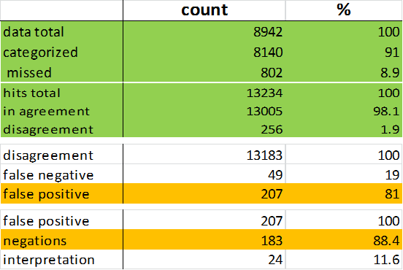

Data have been screened, high quality data have been selected and transported to the SyS database in step 3. So far in step 4, syndromes have been defined and each case (record) in the data has been classified into one of the defined syndromes. We can now convert the data into time series (Figure 6). Each syndrome that is included in the SyS must be converted to a single time series. This is a relatively simple process that can be easily automated. Difficulties may arise due to different formats for recording time, and these should be considered when evaluating data for inclusion in the SyS (Step 3) and may be dealt with in data pre-processing (Step 5).

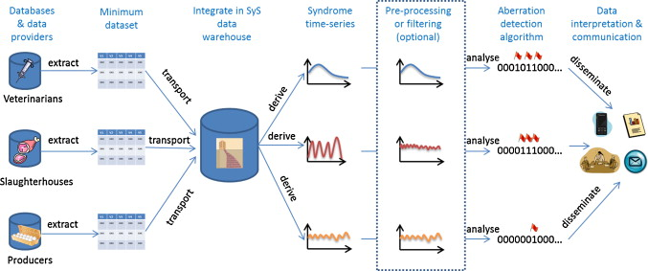
Figure 6: Schematic representation of animal health data flow in a SyS system. Reproduced from [26]

Describe syndrome time-series?
Box 12: FLEKO [62]
Pigs, cattle and small ruminants constitute 97% of all slaughters recorded in the FLEKO (the rest being made up of rabbits, horses and farmed game). Poultry is a production sector (including slaughter) that is separate from cattle, pigs and small ruminants in Switzerland so that the estimated 55 million birds slaughtered annually (Swiss Farmer Union) are not reported to the FLEKO. Pigs were the most numerous production animals sent to the slaughterhouses between 2007–2012, representing 75% of all normal slaughters declared to the FLEKO. Cattle came second (17%), followed by small ruminants (7%) (Table 2). However, nearly two-thirds of all emergency slaughters were cattle (64%), followed by pigs (33%) with small ruminants only accounting for 3% of emergency slaughters.

We observed a peak in the number of pigs slaughtered in December, and a peak in March for cattle and small ruminants slaughter. A similar pattern was observed for emergency slaughters (Table 3). However, the seasonality pattern observed in the number of carcass condemnations (during both normal and emergency slaughters) was different. We found that the number of condemnations peaked in December for both cattle and pigs. This indicates that the number of carcasses condemned is not solely affected by the total number of carcasses inspected but by other factors too, such as the seasonality in the prevalence of production diseases or in reproduction.

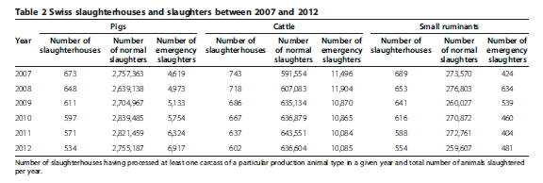

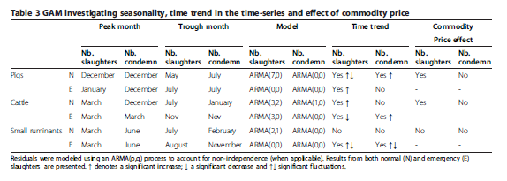

Box 13 : Partial carcass condemnations (PCC) at slaughter [61]
PCC data for cattle were privately made by one Swiss slaughterhouse from canton Fribourg between the dates of 01/01/2009 and 31/12/ 2010. Counts for every month (except October and November) were statistically significantly lower than the January base- line. Counts on Tuesday were significantly higher, and counts on Wednesday and Thursday were significantly lower than on Monday (Table 3). Counts on Friday were not significantly different from the Monday baseline. Year was not significant in the count model.

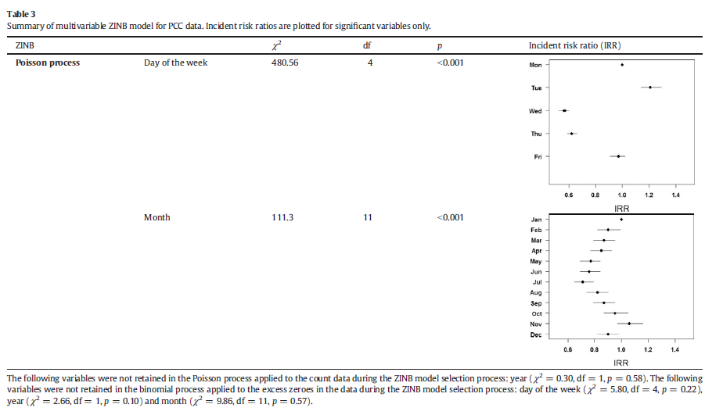

Box 14 : National cattle registry (TVD) [63]
The median difference between the date the event occurred and the date the event was reported to the TVD was one day for deaths and three days for stillbirths. On farm deaths were reported within seven days 81.95% of the time and stillbirths 73.03% of the time.

Deaths were reported to occur more often on Mondays compared to other weekdays and were lower on Saturdays and Sundays. The number of reported deaths was significantly lower on bank holidays and significantly higher the day after a bank holiday compared to other days. A significant, negative trend was observed over the three years.

Box 15 : Pig mortality (rendering) [64]
We obtained four years of pig mortality data (2009-2012) within the four Cantons of Bern, Aargau, Solothurn and Basel-Land (BE, AG, SO and BL), from the rendering firm responsible for the on-farm removal of all animal carcasses (over 200kg) in these regions. The data comprised the date and place of collection, the type of pig, its weight and its ID number. Total counts per type and per canton are presented in Table 1.1. On average, 1 or 2 carcasses were collected every other day (Figure 1.3).

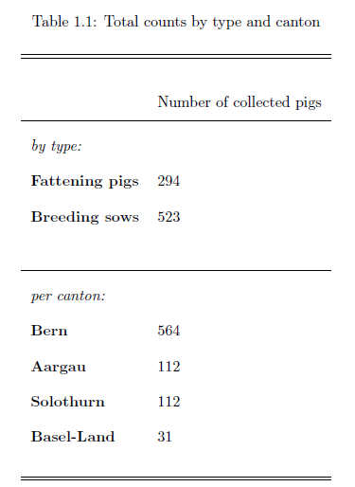
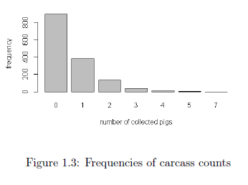

Box 16: Equinella
Equinella is an electronic reporting and information system for equine infectious diseases based on voluntary participation of veterinary practitioners. The system has been in operation since November 2013 and makes use of a web-based application to capture data (Figure 1). Veterinary practitioners interested in becoming an Equinella sentinel veterinarian have to register. These sentinel veterinarians can report diseases as well as certain clinical symptoms : abortion, anaemia of unknown origin, CNS symptoms, death of unknown origin, diarrhea, fever of unknown origin (Figure 2), pruritus, respiratory tract symptoms, weight loss of unknown origin and other [free text]. On the first day of each month, a reminder email is automatically sent to all sentinel veterinarians. Recipients can either confirm that they had no clinical observations of relevance to Equinella in their practice in the previous month or they can report their observations retrospectively.

Box 16: Equinella (continued)
Figure 1: Overall number of reports of clinical symptoms observed in horses, submitted by Equinella sentinel veterinarians since the beginning of the pilot project in November 2013.

Figure 2: Number of reports of fever of unknown origin observed in horses, submitted by Equinella sentinel veterinarians since the beginning of the pilot project in November 2013.

Box 17 : Post-mortems from Vetsuisse Pathology Institute in Bern.
Post-mortem data were collected by the Institute of Animal Pathology (ITPA) of the Veterinary Faculty at the University of Bern between 2000 and 2011. The data comprised approximately 19,000 report entries. We focused on the data from production animals, respectively cattle (2910 entries) and swine (6031 entries). The number of cattle and swine sent to Bern for post-mortem has decreased by more than 70% over the last 10 years, mostly as a result of fewer pigs being autopsied.

The seasonality observed in the number of individuals sent for post-mortem is different for cattle and pigs, and more pronounced in the former.

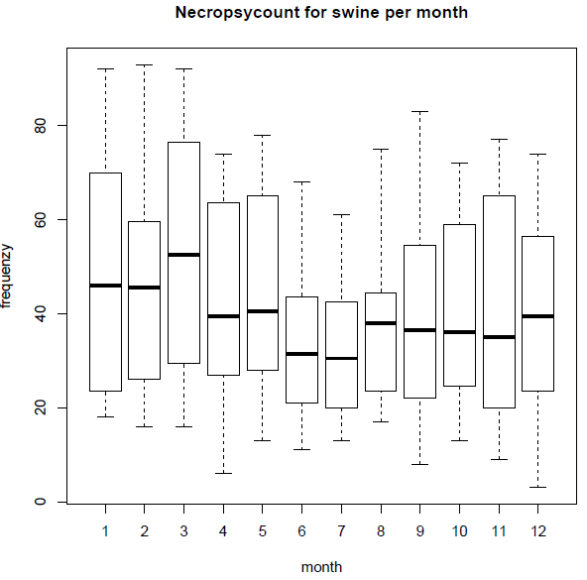
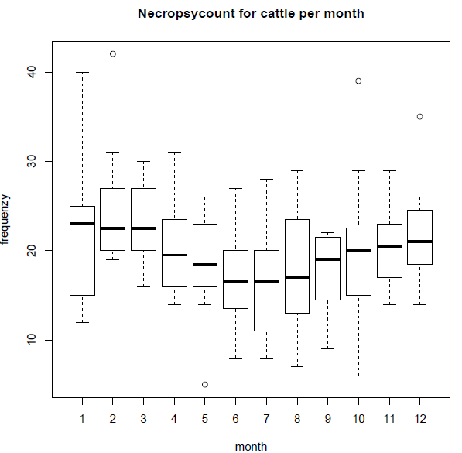

Fit event detection algorithms to each time series & report
Based on the characteristics of the syndrome time series coming out of step 4, the length of historic data available and the type of outbreak the system must detect, different aberration detection algorithms can be tested. There is abundant literature reviewing [46] and/or applying such algorithms available in both human [42] and veterinary [47] literature. Most syndromic surveillance systems apply variants of the standard univariate statistical process control (SPC) methods, for example Shewhart, cumulative sum or exponentially weighted moving average charts [48]. SPC approaches rely on cumulative differences between observed and expected data in a time window when compared with a threshold. A suspicious increase in the observed data over the theoretical mean is evidence for an unspecified outbreak. Other approaches involve comparing observed patterns with those predicted by a model. Typical models for temporal data include regressions and time-series methods, explicitly accounting for seasonality in syndrome incidence for example [49]. Spatial and spatio-temporal data are more suited to analyses using generalised linear mixed models [50] or scan statistics [51]. Syndromes, like diseases, may cluster in space or time. The automated process of cluster identification, using scan statistics for example, can help identify areas or sub-populations that require further epidemiological investigations.

Different algorithms will require different levels of pre-processing. This is the process of identifying and removing explainable patterns, such as temporal dependence (e.g. daily autocorrelation) or seasonality, which may obscure unexplained outbreak events, and whose presence in the data violates standard control-chart assumptions [47,52]. Pre-processing can also be used to deal with the inherent biases, confounders, and missing records which may have been identified in steps 3 and 4.

Relevant algorithms should then be parameterized and optimized for each time series based on achieving or exceeding performance goals based on the disease(s) that must be detected, the smallest outbreak size that must be detected, and the time frame within which detection must occur [22]. Algorithm evaluation will be based on historical outbreak data if available or on the simulation of outbreaks for the disease(s) under surveillance. The performance criteria of these algorithms (sensitivity, specificity, false positive rates or other parameters) may vary with the type of disease under surveillance.

Box 18 : statistical monitoring of condemnation rates from Swiss slaughterhouses [66]
We evaluated, via simulation, the performance of a quasi-Poisson regression (also known as improved Farrington) algorithm for the detection of disease outbreaks during post-mortem inspection of slaughtered animals (cattle and pigs).
One outbreak was added to each simulated baseline series, with a random outbreak size and starting point. Outbreak sizes were randomly generated as Poisson variables with mean equal to k times (with k from 2 to 10) the standard deviation of the baseline count at t_{i}. Outbreak cases were then distributed in time according to a lognormal distribution with mean 0 and standard deviation 0.5 [67]. For each parameter k, 1000 time series were simulated.
The improved Farrington algorithm [67,68] fits a log- linear quasi-Poisson model using the available baseline data. The amount of baseline data used can be chosen so that only recent values; within the time window (2w+1) months from the last b years from the current time point; are included to fit the model:
$E\left[y_{t}\right]= μ_{t}=\left(α+βt+f_{t}\right)*e_{t}$; $Var\left(y_{t}\right)=θ*μ_{t}$ with $θ>1$

The model can include a baseline incidence rate$α$, a trend$β$, a seasonal pattern $f_{t}$and the population offset. When parameterising the algorithm based on the retrospective analyses of 6 years of historic data, the probability of detection was satisfactory for large outbreaks but poor for smaller outbreaks.

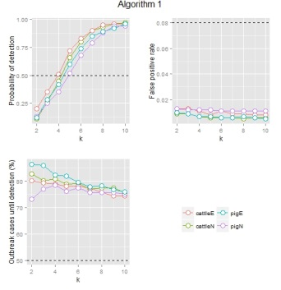

Box 18 : statistical monitoring of condemnation rates from Swiss slaughterhouses [66] (continued)
Varying the amount of historical data used to fit the algorithm can help increasing the probability of detection for smaller outbreaks.

However, while the use of a 0.975 quantile generated a low false positive rate, in most cases, more than 50% of the outbreak cases had already occurred at the time of detection. The high variance observed in the whole carcass condemnations time-series and the lack of flexibility in terms of the temporal distribution of the simulated outbreaks resulting from the reporting frequency (monthly) constitutes a challenge to the early detection of outbreaks in the livestock population based on this type of data. Reporting frequency should be increased in the future to improve timeliness of the SySS while better sensitivity may be achieved by integrating the meat inspection data into a multivariate SySS simultaneously evaluating multiple sources of data on livestock health.

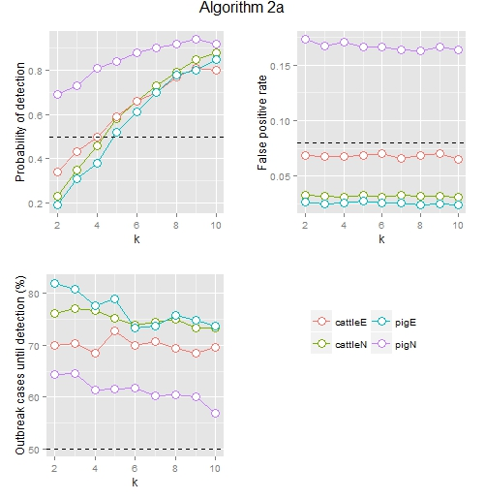

Box 19: Modelling Pig Mortality: Syndromic surveillance in four Swiss Cantons by applying a Poisson point process [64]
We propose a combination of tests covering a weekly, a fortnightly and a four week timespan.
Let $S_{1}\sim Pois(λ_{w,c})$, $S_{2}\sim Pois(λ_{w-1,c})$ and $S_{1}\sim Pois(λ_{(w-2,w-3),c})$ be independent random variables, whereby S1 corresponds to the collected carcass count in week w within canton c, S2 corresponds to the count in the previous week w-1 within the same canton and S3 to the count in weeks w-2 and w-3 combined. To simultaneously check for aberrations in the number of pig carcasses collected over a weekly, a fortnightly and a four week timespan, three separate thresholds were required. We specified the probability that in area A k1 carcasses, or fewer, will be collected during week w, k2 carcasses, or fewer, during weeks w and w -1 combined, and k3 carcasses, or fewer, during weeks w up to w-3:
$$F\left(\vec{λ},\vec{k}\right)= \sum_{i=0}^{k_{1}}{\sum_{j=0}^{k_{2}-k_{1}}{\left(\sum_{r=0}^{i}{e^{{-λ}_{w,A}}} \frac{λ_{w,A}^{r}}{r!}\right)}} \left(\sum_{r=0}^{j}{e^{{-λ}_{w,A}}} \frac{λ_{w,A}^{s}}{s!}\right)\left(\sum_{r=0}^{k_{3}-i-j}{e^{{-2.λ}_{w,A}}} \frac{{2.λ}_{w,A}^{u}}{u!}\right)$$
which can be evaluated for different combinations of values for $k_{1}, k_{2},k_{3 }∈N$
To find the lowest threshold levels $\vec{t}={\left[t_{1},t_{2},t_{3}\right]}^{T}$ while maintaining the overall false alarm rate at α, we created a program using $F_{\vec{λ},\vec{t}}=F\left(\vec{λ,\vec{t}}\right)$ and optimised the combination of thresholds $\vec{t}$ for a given λ.
We simulated the spread of CSF in Switzerland under different outbreak scenarios[65]. Overall, a statistical alarm was raised in 65% of the simulated acute CSF outbreaks and in 48% of the simulated mixed CSF outbreaks (Table 2.4). In 13% of the simulations, the outbreaks were not flagged as a result of the herds passing through the clinical stage into the immune stage undetected, or of the very low number of clinical pigs in the herds (leading to negligible CSF mortality). In 19% of the simulations, some other reason prevented the disease from being detected within the four cantons (e.g. only herds of piglets were heavily affected or only herds outside the four cantons of interest went clinical). In none of these simulations, a statistical alarm could have been raised.



Box 20: Modelling Pig Mortality: Syndromic surveillance in four Swiss Cantons by applying a Poisson point process [64] (continued)
Acute CSF outbreaks were detected earlier than mixed outbreaks (Figure 2). In acute scenarios, the first statistical alarm was flagged on average 7 weeks post-introduction as opposed to a minimum of 11 weeks in the mixed scenarios.
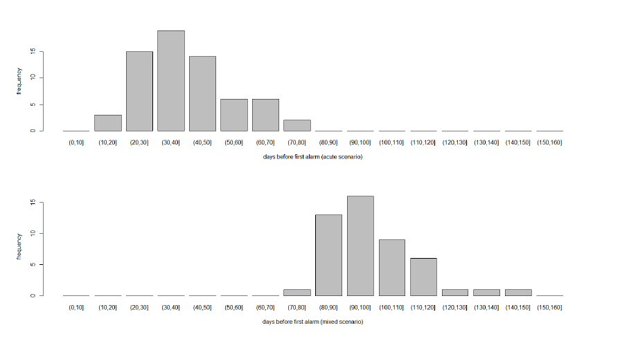

Box 21: Evaluating the ability of temporal aberration-detection algorithms to detect simulated disease outbreaks in routinely collected cattle mortality data
We extracted the daily number of on-farm cattle deaths from the TVD between 2009 and 2011. Negative binomial regression models were used on the historical data to simulate baseline time-series, into which we injected simulated disease outbreaks of different size, duration and shape (n=60,000). The performance of Shewhart, cumulative sum (CuSum) and exponentially weighted moving average (EWMA) control charts were assessed based on several measures including sensitivity (the ability to detect an outbreak when it occurs), false positive rate (FPR - the probability of sounding an alarm when there is no outbreak) and time to detection (TTD). Control charts are being evaluated separately, under different combination rules, and using different detection limits [a full manuscript will follow in the coming months].

Box 22 : Incorporating case reporting delay into the value of evidence from syndromic surveillance
How to take into account reporting delays in outbreak detection algorithms, in syndromic surveillance for example, is not a trivial question. This is, in part, the reason why most surveillance systems use the date of the reception of data, rather than the (often unknown) date of the health event itself. The main drawback of this common approach is the resulting reduction in sensitivity and specificity of the system (Farrington and Andrews, 2004).
In the relatively few systems for which all dates are known, a correction factor can be imputed based on mathematical models adjusting for the underreporting bias owing to the time lag of the reporting process (Lui and Rudy, 1989). In this study, we are integrating the cumulative probability distribution of the reporting delay of death notifications for cattle (Figure 1) into a Bayesian likelihood ratio framework (Anderson, 2014) to provide circumstantial ‘‘evidence’’ of a disease outbreak from an animal syndromic surveillance system [a full manuscript will follow in the coming months].
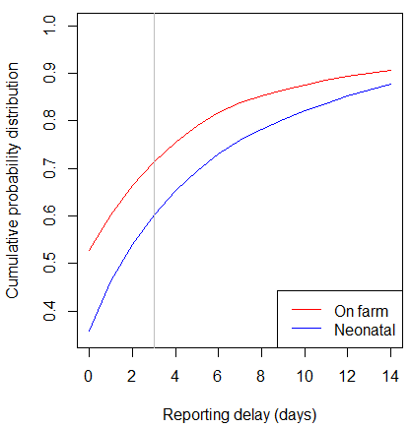
Figure 1: Cumulative probability distribution of the reporting delays for on farm deaths (red) and neonatal deaths (blue) in the TVD. The Swiss legislation states that deaths on farm need to be reported within 3 days (grey line). We focused on reports with relatively short reporting delays (≤ 14 days) which are the most relevant for timely outbreak detection.

Choices will have to be made (often based on decision theory [53]) regarding the alarm thresholds of the algorithms, i.e. above what level of excess syndrome counts is an epidemiological investigation instigated to confirm/identify the health event behind the statistical signal (unlike monitoring systems). Similarly, the frequency of analysis needs to be agreed upon and should be based on the practical possibilities: can the pre-processing and analysis process be automated and run on a daily basis or does it have to be done “manually” by an operator with a statistical background? Even in an automatized system, a process for scheduled evaluation of the performance of the algorithms and re-parameterization (as may be required) should be developed as the baseline behaviour of the time-series (mean, variance…) may change periodically or over a longer time scale. When this happens, the system developers should investigate why it is changing and re-evaluate algorithm performance by injecting outbreaks into the new baseline.

Stakeholders must agree on a communication strategy for the SyS system. Mere accumulation of knowledge without any relevant output is useless. Data interpretation must provide timely and relevant information that meets surveillance objectives. The exact content of the information disseminated will depend on the audience (e.g. general public, system users, decision-makers etc.) but should always include a brief description of how the system works and how the data were analysed; information about the system's performance (e.g. mean/variance of time-series to detect possible change in the baseline) and the degree of confidence in these results; and some epidemiological intelligence (e.g. summary graphs and maps). Such knowledge should then be quickly and effectively disseminated. The dissemination of output to system users and epidemiologists should be done in almost real-time in order for them to assess the potential implications. This is most efficiently done through electronic interchange (e.g. reports can be automatically sent by email to a list of users after each analysis). Such users also have the possibility to access and drill down into the raw data to support a field investigation (see step 6). During non-acute situations, communication to decision-makers may be limited to quarterly reports or meetings, debriefing about the latest observed trends and possible data issues encountered. Dissemination of epidemiological knowledge to other stakeholders (e.g. animal health professionals or researchers) and/or the general public may be done via the Internet, press releases or newsletters. During acute situations (following the confirmation of an alarm in step 6), the analytical output produced by the system should be rapidly presented to the decision makers with advice and recommendations for multiple public health action options. Wider communication should strictly follow the guidelines in place in the relevant animal health authority/ministry. These may include the publication of official statements to the general public and professionals and the use of social media (or more traditional media) to convey the message to a wide audience in a short time.

Define an appropriate response for detected signals
Finally, it is essential to develop a minimally acceptable response protocol for each signal or alarm produced [54]. The first step in investigating an alarm is confirmation of the signal. The individual cases that triggered the alarm must be examined to obtain geographic (and potentially demographic) data. Then if the signal is determined to not be a consequence of duplication of individual case data or data entry error, the specificity of the signal may be increased by:
- Evaluating the absolute number of cases leading to the alarm.
- Validating the alarm using data from other surveillance systems covering the same population (sentinel veterinarian network, pathology data etc.).
- Speaking directly to the individuals who entered the case data.
- Using email lists to query animal health specialists about specific conditions relating to the excess cases in question.
- Requesting additional testing of animals to rule specific diseases in or out. The development of virome analysis using next generation sequencing at the Virology Institute in Bern will enable in the future the unspecific identification of all viruses present in a sample without requiring knowledge of the virus and independent of the existence of specific diagnostic tools.
- Initiating an outbreak investigation.

The nature and magnitude of the event will influence the intensity of the response (from a phone call to veterinarians at the reporting sites to dispatching a team of epidemiologists in the field etc.). This will also depend on the relationship between the indicator and the real health status of the population under surveillance. Statistical alarms produced by systems based on the monitoring of non-specific data should thus be carefully interpreted before being converted into epidemiological alerts and transmitted to field investigators. An in-depth study of the variation factors of the monitored health parameter should be carried out before running the system for surveillance, in order to facilitate the rapid interpretation of anomalies detected day-to-day.

Since both SBS and SNS monitor pre-diagnostic indicators, a signal from either type of SyS will require an immediate investigation to determine whether there is an ongoing outbreak in the population and to identify the cause. However the magnitude, intensity and nature of the investigation will likely be different depending on whether the SyS is an SBS or SNS system. Because SBS monitors a specific disease or group of related diseases, SBS provides some information on which to focus an outbreak investigation (i.e. an increase in submissions for Brucella testing would suggest at Brucella-like disease outbreak). SNS however may provide little additional information to guide an outbreak investigation. An unexpected increase in the number of dead stock picked up by a rendering company could be caused by an outbreak of any one of a large number of candidate diseases. In the case of a signal from a SNS outbreak investigation would by necessity cast a large net and be very nonspecific.

Evaluation
All SyS systems should be evaluated periodically to assess whether the surveillance objectives (established in step 1) are met; whether steps 2–6 of the system are functional; and what the users’ perspective of the system (i.e. is the system useful) is. Two main general approaches to evaluating surveillance have been used: quantitative and qualitative. In quantitative evaluations, a set of characteristics of the surveillance system is scored to indicate how good the surveillance system is relative to some ideal. In qualitative evaluations, text descriptions are used to evaluate each characteristic. Both approaches are useful, but the qualitative approach tends to provide more clues about how to improve a system.
There are many different characteristics that have been used to evaluate surveillance (Table 3). For each characteristic, the evaluation should describe the surveillance system, and then provide a critical assessment. For instance, when considering the characteristic of timeliness, the evaluation should first describe what delays there are in getting surveillance data from the field to the decision makers, and then assess the impact or importance of this. Is it fast enough? If not, how important are the delays? Is this a major weakness with the system, or just something that it would be good to improve, if possible?

The evaluation process will take into account:
- The policy purpose and surveillance objectives (Step 1)
- The nature of the animal populations under surveillance
- The resources available (the resource constraints for the surveillance)
- The regulatory environment (key laws and regulations under which the surveillance is undertaken
- The stakeholders (groups of people with an interest in the surveillance evaluation)

Table 3: Evaluating the surveillance system against a range of different characteristics. The most important characteristics are highlighted with the symbol (!!), while the others may be included if they appear to be useful but may be omitted otherwise. Reproduced from [55]

Theme | Evaluation characteristic
Surveillance objectives | Relevance (!!)  Consistency with disease situation  Recognition of stakeholders needs  Completeness, level of detail, adequate to guide and evaluate  surveillance
Surveillance approach | Appropriateness of chosen approach (!!)  Standardisation and documentation of procedures
Population | Target population (population of interest) (!!)  Study population (population under surveillance) (!!)  Unit of interest (animal, household, herd/flock etc) (!!)  Epidemiological unit (!!)  Coverage (!!)  Distribution (!!)
Sampling | Selection method (!!)  Representativeness (!!)
Data and specimens | Primary data (!!)  Data type  Data source (!!)  Standardisation of data collection tools
Tests ª | Tests used in the surveillance systems (!!)  Case definition (!!)  Test sensitivity (!!)  Test specificity (!!)  Practicality, availability and cost  Test decision tree to describe testing scheme and basis for  definitive diagnosis (!!)
ª may not be applicable to SyS

Table 3 (continued)
Theme | Evaluation characteristic
Data management  and communication | Form of the primary data collected (paper, electronic, verbal)  Information flow diagram (!!)  Timeliness (!!)  Feedback systems (!!)  Security  Interoperability
Stakeholders | Awareness  Ownership  Acceptability (!!)  Participation (!!)  Feedback/communication/exchange systems  Utility/benefit (!!)
Quantitative measures  of surveillance quality | Surveillance sensitivity  Surveillance negative predictive value (!!)  Bias and precision (!!)  Detection fraction (!!)  Animal or group-level sensitivity and specificity  Test positive predictive value  Test negative predictive value
Cost and inputs | Direct surveillance budget (!!)  Indirect financial support  Veterinary service resources  Non-government resources used
Utility, outputs and impact | Outputs (!!)  Benefits (!!)  Impacts (!!)  Efficiency (!!)  Effectiveness

Table 3 (continued)
Theme | Evaluation characteristic
Quality control | Surveillance monitoring system
Future operation | Flexibility  Multiple utility  Portability  Robustness  Resilience  Stability  Sustainability (!!)
Summary evaluations | Fitness for purpose (!!)  Usefulness  Simplicity  Practicality (!!)  Cost-effectiveness  Cost-benefit

The actual evaluation process should be carried out by an independent party who is not associated with the SyS and who will be more likely to provide an unbiased evaluation. Evaluation indicators for public health systems in general, or public health SyS systems in particular have been extensively presented in the literature [14,15,19,37,38,56]. Indicators such as data quality, compliance, costs, acceptability, usefulness, validity and timeliness will also apply when evaluating animal SyS. It is important to note that evaluation indicators may vary for systems with different surveillance purposes [57]. The evaluation indicators may be measured through focus groups or interviews involving system users and decision makers [6,58]. System reliability may be measured during or immediately after significant health events [59]; or at the very least through outbreak simulations (to specifically evaluate algorithms as in step 5). The outcomes of the evaluation process are critically important since they will include recommendations for actions to improve quality, efficiency, and usefulness which should be widely communicated to all stakeholders [6]. Such recommendations should be fed back into steps 1–6 of our proposed approach (Fig. 1) and set standards for the next round of evaluation.

References
1. Triple-S: Syndromic Surveillance Systems in Europe (2014) Guidelines for designing and implementing a syndromic surveillance system.
2. Dórea FC, Sanchez J, Revie CW (2011) Veterinary syndromic surveillance: Current initiatives and potential for development. Prev Vet Med 101: 1–17.
3. Bravata DM, McDonald KM, Smith WM, Rydzak C, Szeto H, et al. (2004) Systematic review: surveillance systems for early detection of bioterrorism-related diseases. Ann Intern Med 140: 910–922.
4. Mandl KD, Overhage JM, Wagner MM, Lober WB, Sebastiani P, et al. (2004) Implementing Syndromic Surveillance: A Practical Guide Informed by the Early Experience. J Am Med Informatics Assoc 11: 141–150.
5. Yahav I, Shmueli G (2007) Algorithm Combination for Improved Performance in Biosurveillance Systems. Intell Secur Informatics Biosurveillance: 91–102.
6. Del Rocio Amezcua M, Pearl DL, Friendship R, McNab WB (2010) Evaluation of a veterinary-based syndromic surveillance system implemented for swine. Can J Vet Res 74: 241–251.
7. Hyder K, Vidal-Diez A, Lawes J, Sayers AR, Milnes A, et al. (2011) Use of spatiotemporal analysis of laboratory submission data to identify potential outbreaks of new or emerging diseases in cattle in Great Britain. BMC Vet Res 7: 14.
8. Odoi A, Carter CN, Riley JW, Smith JL, Dwyer RM (2009) Application of an automated surveillance-data-analysis system in a laboratory-based early-warning system for detection of an abortion outbreak in mares. Am J Vet Res 70: 247–256.
9. Metre D Van, Barkey D (2009) Development of a syndromic surveillance system for detection of disease among livestock entering an auction market. J Am Vet Med Assoc 234: 658–664.
10. Warns-Petit E, Morignat E, Artois M, Calavas D (2010) Unsupervised clustering of wildlife necropsy data for syndromic surveillance. BMC Vet Res 6: 56.
11. Gibbens JC, Robertson S, Willmington J, Milnes A, Ryan JBM, et al. (2008) Use of laboratory data to reduce the time taken to detect new diseases: VIDA to FarmFile. Vet Rec 162: 771–776. doi:10.1136/vr.162.24.771.
12. Perrin J-B, Ducrot C, Vinard J-L, Morignat E, Gauffier A, et al. (2010) Using the National Cattle Register to estimate the excess mortality during an epidemic: application to an outbreak of Bluetongue serotype 8. Epidemics 2: 207–214.
13. Stege H, Bager F, Jacobsen E, Thougaard A (2003) VETSTAT—the Danish system for surveillance of the veterinary use of drugs for production animals. Prev Vet Med 57: 105–115. doi:10.1016/S0167-5877(02)00233-7.
14. Hoinville LJ, Alban L, Drewe JA, Gibbens JC, Gustafson L, et al. (2013) Proposed terms and concepts for describing and evaluating animal-health surveillance systems. Prev Vet Med null.
15. Salman MD, editor (2003) Animal disease surveillance and survey systems: methods and applications. Iowa State Press.
16. El Allaki F, Bigras-Poulin M, Michel P, Ravel A (2012) A Population Health Surveillance Theory. Epidemiol Health 34: 1–8. doi:10.4178/epih/e2012007.
17. Christensen J (2012) A practical framework for conducting Foreign Animal Disease surveillance. Prev Vet Med 105: 271–279. doi:10.1016/j.prevetmed.2012.01.008.
18. Hadorn DC, Haracic SS, Stärk KDC (2008) Comparative assessment of passive surveillance in disease-free and endemic situation: example of Brucella melitensis surveillance in Switzerland and in Bosnia and Herzegovina. BMC Vet Res 4: 52. doi:10.1186/1746-6148-4-52.
19. Hendrikx P, Gay E, Chazel M, Moutou F, Danan C, et al. (2011) OASIS: an assessment tool of epidemiological surveillance systems in animal health and food safety. Epidemiol Infect 139: 1486–1496. doi:10.1017/S0950268811000161.
20. Centers for Epidemiology and Animal Health (2006) Surveillance and Data Standards for USDA APHIS Veterinary Services. Available: http://www.aphis.usda.gov/wps/wcm/connect/aphis_content_library/sa_our_focus/sa_animal_health/sa_monitoring_and_surveillance/sa_nahss/ct_resources#standards.
21. Defra (2012) Surveillance Advisory Group Final Report. Available: http://webarchive.nationalarchives.gov.uk/20140707135733/http://www.defra.gov.uk/ahvla-en/files/pub-sag-final-report.pdf/.
22. Wagner MM, Shaffer L, Shepard R (2006) Functional requirements for biosurveillance. In: Wagner MM, Moore AW, Aryel RM, editors. Handbook of Biosurveillance. Elsevier Academic Press.
23. Buckeridge DL (2007) Outbreak detection through automated surveillance: a review of the determinants of detection. J Biomed Inform 40: 370–379. doi:10.1016/j.jbi.2006.09.003.
24. Buckeridge DL, Burkom H, Moore A, Pavlin J, Cutchis P, et al. (2004) Evaluation of Syndromic Surveillance Systems --- Design of an Epidemic Simulation Model. Morb Mortal Wkly Rep 53: 137–143.
25. Dupuy C, Bronner A, Watson E, Wuyckhuise-Sjouke L, Reist M, et al. (2013) Inventory of veterinary syndromic surveillance initiatives in Europe (Triple-S project): Current situation and perspectives. Prev Vet Med 111: 220–229. doi:10.1016/j.prevetmed.2013.06.005.
26. Vial F, Berezowski J (2014) A practical approach to designing syndromic surveillance systems for livestock and poultry. Prev Vet Med. doi:10.1016/j.prevetmed.2014.11.015.
27. Häsler B, Howe KS, Stärk KDC (2011) Conceptualising the technical relationship of animal disease surveillance to intervention and mitigation as a basis for economic analysis. BMC Health Serv Res 11: 225. doi:10.1186/1472-6963-11-225.
28. Hendrikx P, GAY E, Chazel M, Moutou F, DANAN C, et al. (2011) OASIS: an assessment tool of epidemiological surveillance systems in animal health and food safety. Epidemiol Infect 139: 1486–1496. doi:10.1017/S0950268811000161.
29. Katz R, May L, Baker J, Test E (2011) Redefining syndromic surveillance. J Epidemiol Glob Health 1: 21–31. doi:10.1016/j.jegh.2011.06.003.
30. Perrin J-B, Ducrot C, Vinard J-L, Morignat E, Calavas D, et al. (2012) Assessment of the utility of routinely collected cattle census and disposal data for syndromic surveillance. Prev Vet Med 105: 244–252. doi:10.1016/j.prevetmed.2011.12.015.
31. Madouasse A, Marceau A, Lehébel A, Brouwer-Middelesch H, van Schaik G, et al. (2013) Evaluation of a continuous indicator for syndromic surveillance through simulation. application to vector borne disease emergence detection in cattle using milk yield. PLoS One 8: e73726. doi:10.1371/journal.pone.0073726.
32. Zurbrigg KJ, Van den Borre NM (2013) Factors associated with good compliance and long-term sustainability in a practitioner-based livestock disease surveillance system. Can Vet J 54: 243–248.
33. O’Sullivan TL, Friendship RM, Pearl DL, McEwen B, Dewey CE, et al. (2012) Identifying an outbreak of a novel swine disease using test requests for porcine reproductive and respiratory syndrome as a syndromic surveillance tool. BMC Vet Res 8: 192. doi:10.1186/1746-6148-8-192.
34. Dupuy C, Morignat E, Dorea F, Ducrot C, Calavas D, et al. (2015) Pilot simulation study using meat inspection data for syndromic surveillance: use of whole carcass condemnation of adult cattle to assess the performance of several algorithms for outbreak detection. Epidemiol Infect: 1–11. doi:10.1017/S0950268814003495.
35. Kloeze H, Berezowski J, Bergeron L, de With N, Duizer G, et al. (2012) A Minimum Data Set of Animal Health Laboratory Data to allow for Collation and Analysis across Jurisdictions for the Purpose of Surveillance. Transbound Emerg Dis 59: 264–268. doi:10.1111/j.1865-1682.2011.01264.x.
36. Anholt RM, Berezowski J, Maclean K, Russell ML, Jamal I, et al. (2014) The application of medical informatics to the veterinary management programs at companion animal practices in Alberta, Canada: a case study. Prev Vet Med 113: 165–174. doi:10.1016/j.prevetmed.2013.11.005.
37. CDC guidelines working group (2001) Updated Guidelines for Evaluating Public Health Surveillance Systems. Morb Mortal Wkly Rep 50: 1–35.
38. Buehler JW, Hopkins RS, Overhage JM, Sosin DM, Tong V (2004) Framework for Evaluating Public Health Surveillance Systems for Early Detection of Outbreaks: Recommendations from the CDC Working Group. Morb Mortal Wkly Rep 53: 1–11.
39. Berezowski J, Checkley S, Clarke R, Clarke S, Dary C, et al. (2011) The Alberta veterinary practice surveillance network: a veterinary practice surveillance system for cattle in Alberta, Canada. International Conference on Animal Health Surveillance (ICAHS), Lyon, France, 17-20 May, 2011. Association pour l’Étude de l'Épidémiologie des Maladies Animales. pp. 32–34.
40. Klopfenstein C, Berezowski J, Byra C, Brokhoff E, Hurnik D, et al. (2012) The Canadian swine health intelligence network. Int Symp Vet Epidemiol Econ Proc ISVEE13.
41. CDC (1997) Case definitions for infectious conditions under public health surveillance. Morb Mortal Wkly Rep 46: 1–55.
42. Buckeridge DL, Burkom HH, Campbell M, Hogan WR, Moore AW (2005) Algorithms for rapid outbreak detection: a research synthesis. J Biomed Inform 38: 99–113. doi:10.1016/j.jbi.2004.11.007.
43. Dórea FC, Muckle CA, Kelton D, McClure J, McEwen BJ, et al. (2013) Exploratory Analysis of Methods for Automated Classification of Laboratory Test Orders into Syndromic Groups in Veterinary Medicine. PLoS One 8: e57334. doi:10.1371/journal.pone.0057334.
44. Woodall WH, Tech V (2006) The Use of Control Charts in Surveillance. 38.
45. Shmueli G, Burkom H (2010) Statistical Challenges Facing Early Outbreak Detection in Biosurveillance. Technometrics 52: 39–51. doi:10.1198/TECH.2010.06134.
46. Unkel S, Farrington CP, Garthwaite PH, Robertson C, Andrews N (2012) Statistical methods for the prospective detection of infectious disease outbreaks: a review. J R Stat Soc Ser A (Statistics Soc 175: 49–82. doi:10.1111/j.1467-985X.2011.00714.x.
47. Dórea FC, McEwen BJ, McNab WB, Revie CW, Sanchez J (2013) Syndromic surveillance using veterinary laboratory data: data pre-processing and algorithm performance evaluation. J R Soc Interface 10: 20130114. doi:10.1098/rsif.2013.0114.
48. Woodall WH (2006) The use of control charts in health-care and public-health surveillance. J Qual Technol 38: 89–104.
49. Shmueli G, Burkom H (2010) Statistical Challenges Facing Early Outbreak Detection in Biosurveillance. Technometrics 52: 39–51.
50. Kleinman KP, Lazarus R, Platt R (2004) A generalized linear mixed models approach for detecting incident clusters of disease in small areas, with an application to biological terrorism. Am J Epidemiol 159: 217–224.
51. Kleinman KP, Abrams AM, Kulldorff M, Platt R (2005) A model-adjusted space-time scan statistic with an application to syndromic surveillance. Epidemiol Infect 133: 409–419.
52. Lotze T, Murphy S, Shmueli G (2008) Implementation and Comparison of Preprocessing Methods for Biosurveillance Data. Adv Dis Surveill 6: 1–20.
53. Wagner M, Tsui F, Cooper G, Espino JU, Harkema H, et al. (2011) Probabilistic, Decision-theoretic Disease Surveillance and Control. Online J Public Health Inform 3: 1–16. doi:10.5210/ojphi.v3i3.3798.
54. Duchin JS (2003) Epidemiological response to syndromic surveillance signals. J Urban Health 80: i115–i116.
55. Cameron A (2012) Manual of Basic Animal Disease Surveillance.
56. Drewe JA, Hoinville LJ, Cook AJC, Floyd T, Gunn G, et al. (2013) SERVAL: A New Framework for the Evaluation of Animal Health Surveillance. Transbound Emerg Dis.
57. Drewe JA, Hoinville LJ, Cook AJC, Floyd T, Gunn G, et al. (2013) SERVAL: A New Framework for the Evaluation of Animal Health Surveillance. Transbound Emerg Dis: 1–13. doi:10.1111/tbed.12063.
58. Reeder B, Revere D, Olson DR, Lober WB (2011) Perceived usefulness of a distributed community-based syndromic surveillance system: a pilot qualitative evaluation study. BMC Res Notes 4: 187. doi:10.1186/1756-0500-4-187.
59. Josseran L, Fouillet A, Caillère N, Brun-Ney D, Ilef D, et al. (2010) Assessment of a syndromic surveillance system based on morbidity data: results from the Oscour network during a heat wave. PLoS One 5: e11984. doi:10.1371/journal.pone.0011984.
60. Vial F, Reist M (2014) Evaluation of Swiss slaughterhouse data for integration in a syndromic surveillance system. BMC Vet Res 10: 33.
61. Vial F, Reist M (2015) Comparison of whole carcass condemnation and partial carcass condemnation data for integration in a national syndromic surveillance system: The Swiss experience. Meat Sci 101: 48–55. doi:10.1016/j.meatsci.2014.11.002.
62. Vial F, Reist M (2014) Evaluation of Swiss slaughterhouse data for integration in a syndromic surveillance system. BMC Vet Res 10: 33. doi:10.1186/1746-6148-10-33.
63. Struchen R, Reist M, Zinsstag J, Vial F (2015) Investigating the potential of reported cattle mortality data in Switzerland for syndromic surveillance. submitted.
64. Eleo van der Lans (2015) Modelling Pig Mortality: Syndromic surveillance in four Swiss Cantons by applying a Poisson point process Universität Bern.
65. Dürr S, Zu Dohna H, Di Labio E, Carpenter TE, Doherr MG (2013) Evaluation of control and surveillance strategies for classical swine fever using a simulation model. Prev Vet Med 108: 73–84. doi:10.1016/j.prevetmed.2012.07.006.
66. Sarah Thommen (2014) Statistical Monitoring of Condemnation Rates from Swiss Slaughterhouses University of Zürich.
67. Noufaily A, Enki DG, Farrington P, Garthwaite PH, Andrews NJ, et al. (2013) An improved algorithm for outbreak detection in multiple surveillance systems. Stat Med 32: 1206–1222. doi:10.1002/sim.5595.
68. Farrington CP, Andrews NJ, Beale AD, Catchpole MA (1996) A Statistical Algorithm for the Early Detection of Outbreaks of Infectious Disease. J R Stat Soc 159: 547–563.

Appendices

Vial F, Berezowski J (2014) A practical approach to designing syndromic surveillance systems for livestock and poultry. Prev Vet Med.

Vial F, Reist M (2014) Evaluation of Swiss slaughterhouse data for integration in a syndromic surveillance system. BMC Vet Res .
Vial F, Reist M (2015) Comparison of whole carcass condemnation and partial carcass condemnation data for integration in a national syndromic surveillance system: The Swiss experience. Meat Sci.
Andersson MG, Faverjon C, Vial F, Legrand L, Leblond A (2014) Using bayes’ rule to define the value of evidence from syndromic surveillance. PLoS One .
Dórea FC, Dupuy C, Vial F, Reynolds TL, Akkina JE (2014) Toward One Health: are public health stakeholders aware of the field of animal health? Infect Ecol Epidemiol.
Statistical Monitoring of Condemnation Rates from Swiss Slaughterhouses. Master Thesis in Biostatistics (STA495) by Sarah Thommen
Vial, F., Thommen, S. & Held, L., (2015) A simulation study on the statistical monitoring of condemnation rates from slaughterhouses for syndromic surveillance: an evaluation based on Swiss data. Epidemiology and Infection
Modelling Pig Mortality: Syndromic surveillance in four Swiss Cantons by applying a Poisson point process. Masterarbeit der Philosophisch-naturwissenschaftlichen Fakultät der Universität Bern vorgelegt von Eleo van der Lans 2015
Struchen, R. et al., 2015. Investigating the potential of reported cattle mortality data in Switzerland for syndromic surveillance. Preventive Veterinary Medicine.
Vial F, Schärrer S, Reist M (2015) Risk Factors for Whole Carcass Condemnations in the Swiss Slaughter Cattle Population. PLoS ONE
Surveillance & information for action: Real-time reporting and interactive visualization of animal health and slaughterhouse surveillance data in Switzerland [submitted draft]
Experiences with a voluntary surveillance system for early detection of diseases in Switzerland: participation of veterinary practitioners and the perceived usefulness of mobile reporting [submitted draft]
Evaluating the ability of temporal aberration-detection algorithms to detect simulated disease outbreaks in routinely collected cattle mortality data | In prep.
Aggregating epidemiological evidence through multivariate syndromic surveillance: methodological challenges with a particular focus on animal health data | In prep.
Bayesian approaches to syndromic surveillance: a review and introduction for epidemiologists | In prep.
Incorporating case reporting delay into the value of evidence from syndromic surveillance | In prep.

Parts of the following section are reproduced from [1] Dórea FC, Sanchez J. and Revie CW. Veterinary syndromic surveillance: Current initiatives and potential for development. Prev. Vet. Med. Aug. 2011; 101: 1–17.
http://www.syndromicsurveillance.eu/
Parts of the following section are reproduced from [55] Cameron A. Manual of Basic Animal Disease Surveillance, Interafrican Bureau for Animal Resources, African Union, Nairobi, Kenya, 2012.

